**Python**

**What is Python?**

Python is a very high-level programming language, it is effortless to learn. It was created by **Guido van Rossum, and released in 1991.**

**Definition:**

**Python is a high-level, general-purpose programming language.** Its design philosophy emphasizes code readability with the use of significant indentation. Python is dynamically typed and garbage-collected. It supports multiple programming paradigms, including structured, object-oriented and functional programming.

Designed by: **Guido van Rossum**

Developer: **Python Software Foundation**

Filename extensions: .**py,.pyw,.pyz,.pyi,.pyc,.pyd**

First appeared: **20 February 1991; 33 years ago**

Paradigm: Multi-paradigm: **object-oriented, procedural (imperative), functional, structured, reflective**

Stable release: **3.12.3 / 9 April 2024; 41 days ago**

Typing discipline: **duck, dynamic, strong; optional type annotations (since 3.5, but those hints are ignored, except with unofficial tools)**

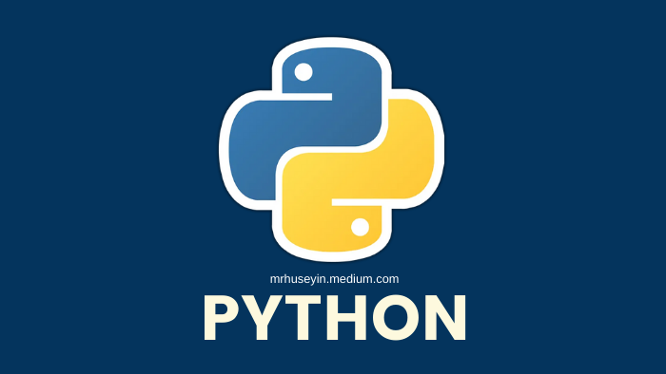

**It is used for?**

* Web development (server-side).
* Software development.
* Mathematics.
* System scripting.

**Advantages:**

* Easy to Read and Learn.
* Reduces Maintenance Cost.
* Avoid the Harm of Software Bugs.
* Wide Applicability.
* Easy Memory Management.
* Large Community.
* Asynchronous Coding.
* Integration with Other Languages.

**Disadvantages:**

* Python is Slow at Runtime.
* Mobile Application Development.
* Difficulty in Using Other Languages.
* High Memory Consumption.
* Not used in the Enterprise Development Sector.
* Runtime Errors.
* Simplicity.

**Features:** 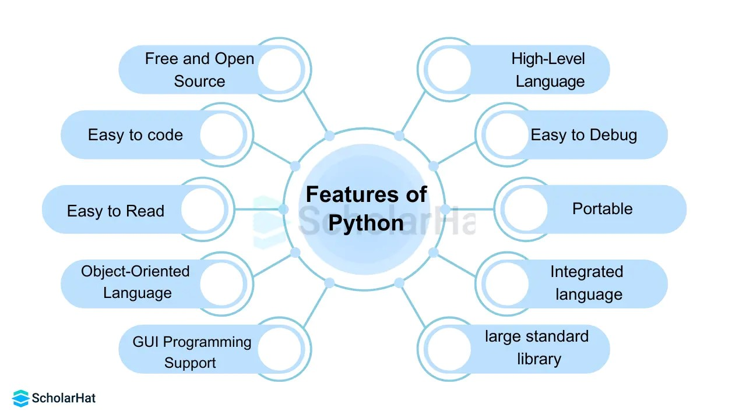

**1.Build and deploy python applications in manual process?**

* Go to EC2 instance.
* Select Ubuntu server.
* Edit inbound rules.
* Launch EC2 instance.

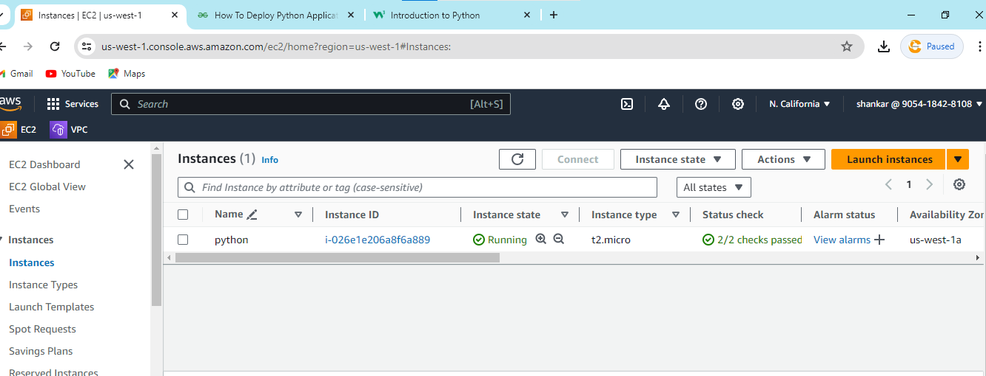

**Step 1: (Flask-Library-app)**

* Connect to Git Bash.
* Go to Git Bash.
* Update Ubuntu machine using these following command as

< sudo apt update >

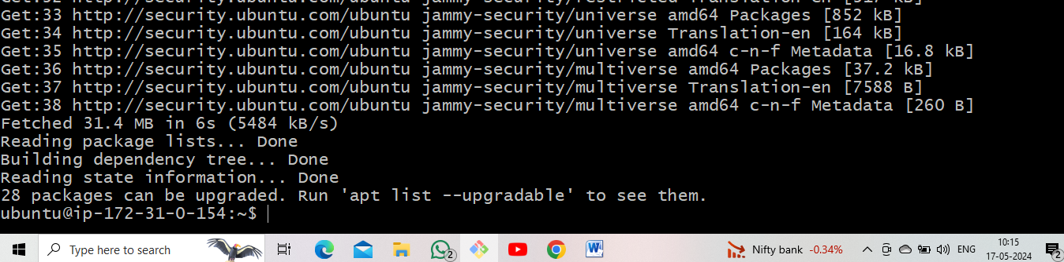

* Full upgrade the machine using these following command as

< sudo apt-get full-upgrade –y >

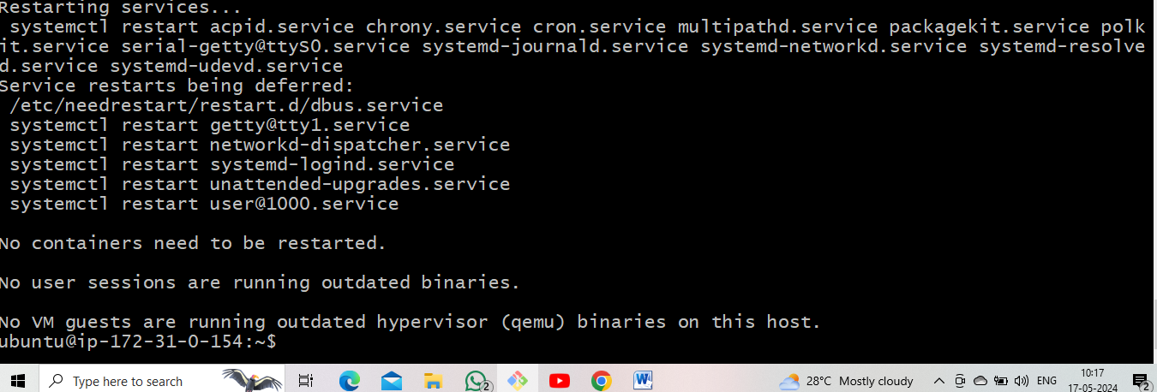

* Install required packages or tools related for deployment project.
* Install python and pip using these command as follows

< sudo apt-get install python-3 pip >

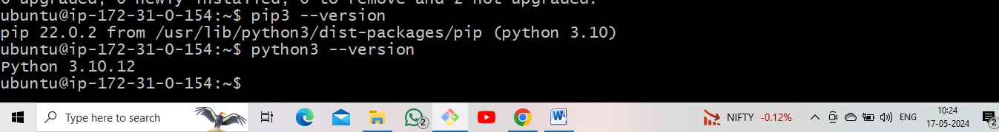

* Check the status

< pip3 --version>

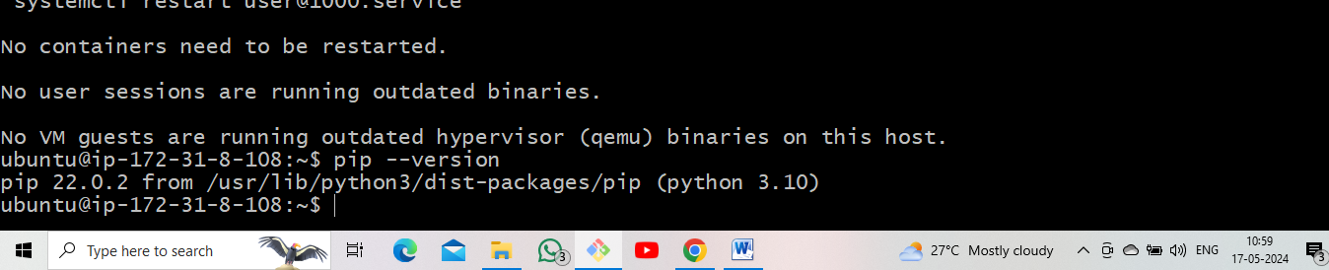

* Install git and clone the project source code from Git Hub.

< sudo git clone (repo name) >

* After that using run these following commands as Git Bash.

< cd (repo name) >

* Install requirements packages

< pip3 install –r requirements.txt >

* After running python app.py. It will generate local host IP address. using these command as

< sudo vi app. py >

* After run flask server
* Go to EC2 instance, copy public ip and paste it Google

< copy public ip : port number>

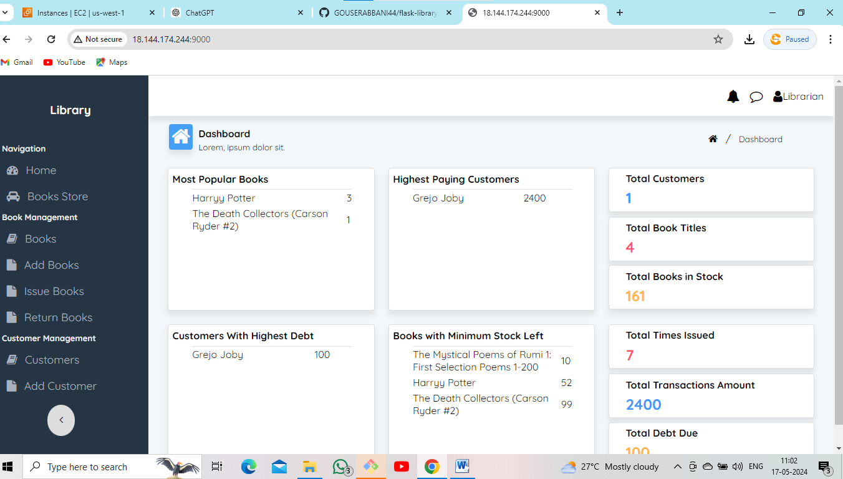

**Step 2: (Fish)**

* Using these command as follows

< sudo git clone (repo name) >

* Change the name

< cd (repo name) >

* Install requirements packages using these command as follows

< pip3 install -r requirements.txt >

* After that change the port number open the file as

< sudo vi app.py >

* Run the server using these command as

< python3 app.py >

* Go to EC2 instance, Edit inbound rules and save it, copy public ip and paste to Google.

<public ip : port number >

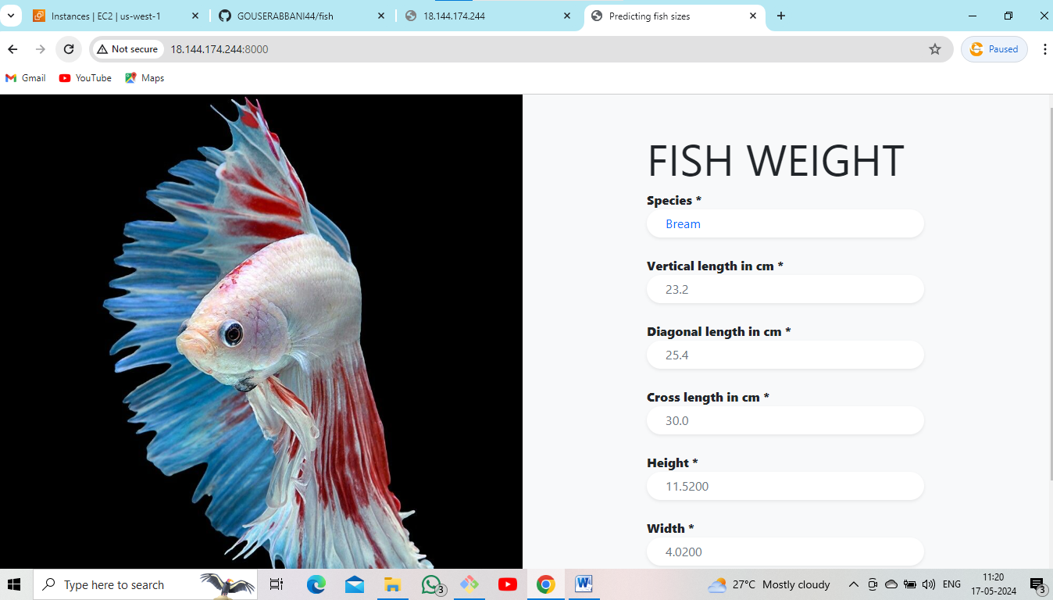

**Step 3: ( Flight - Prediction)**

* Using these command as follows

< sudo git clone (repo name) >

* Change the name

< cd (repo name) >

* Install requirements packages using these command as follows

< pip3 install -r requirements.txt >

* After that change the port number open the file as

< sudo vi app.py >

* Run the server using these command as

< python3 app.py >

* Go to EC2 instance, Edit inbound rules and save it, copy public ip and paste to Google.

<public ip : port number >



**Step 4: (Penguin)**

* Using these command as follows

< sudo git clone (repo name) >

* Change the name

< cd (repo name) >

* Install requirements packages using these command as follows

< pip3 install -r requirements.txt >

* After that change the port number open the file as

< sudo vi app.py >

* Run the server using these command as

< python3 app.py >

* Go to EC2 instance, Edit inbound rules and save it, copy public ip and paste to Google.

< public ip : port number >

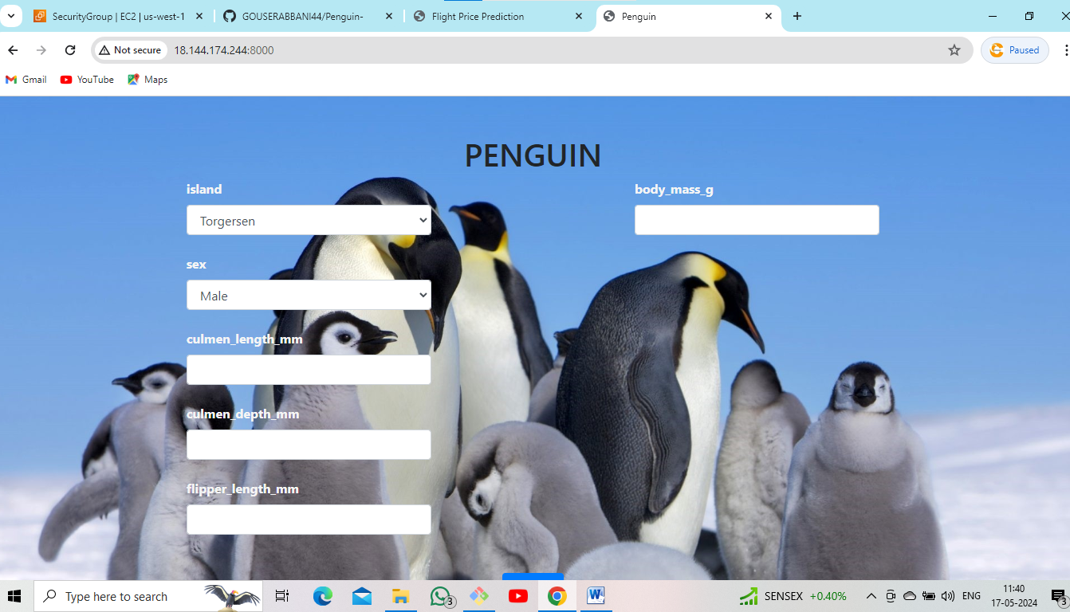

**Step 5: (Car - Prediction)**

* Using these command as follows

< sudo git clone (repo name) >

* Change the name

< cd (repo name) >

* Install requirements packages using these command as follows

< pip3 install -r requirements.txt >

* After that change the port number open the file as

< sudo vi app.py >

* Run the server using these command as

< python3 app.py >

* Go to EC2 instance, Edit inbound rules and save it, copy public ip and paste to Google.

< public ip : port number >

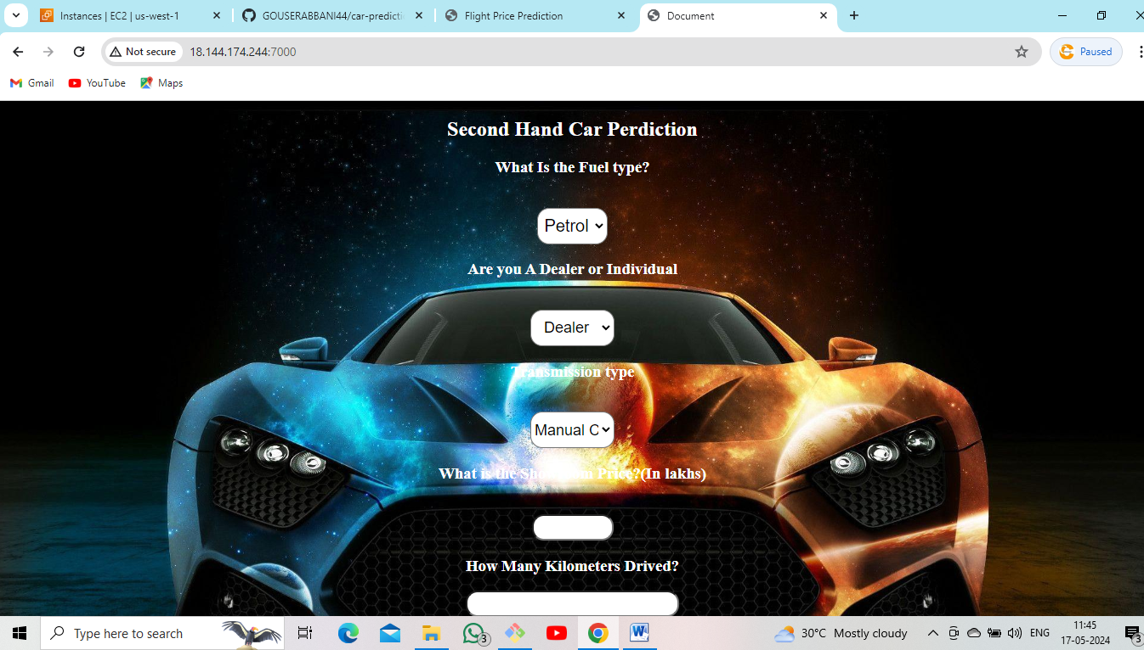

**Step 6: (Medical Insurance)**

* Using these command as follows

< sudo git clone (repo name) >

* Change the name

< cd (repo name) >

* Install requirements packages using these command as follows

< pip3 install -r requirements.txt >

* After that change the port number open the file as

< sudo vi app.py >

* Run the server using these command as

< python3 app.py >

* Go to EC2 instance, Edit inbound rules and save it, copy public ip and paste to Google.

< public ip : port number >

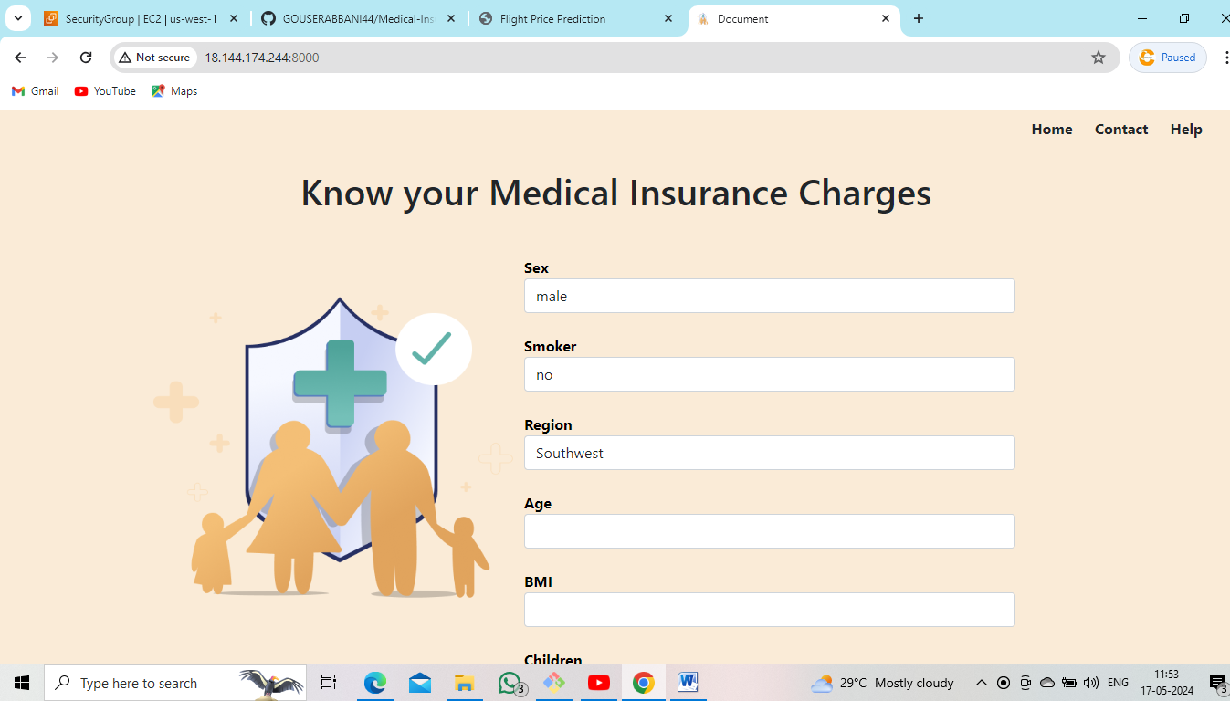

**Step 7: (Portofolio)**

* Using these command as follows

< sudo git clone (repo name) >

* Change the name

< cd (repo name) >

* Install requirements packages using these command as follows

< pip3 install -r requirements.txt >

* After that change the port number open the file as

< sudo vi app.py >

* Run the server using these command as

< python3 app.py >

* Go to EC2 instance, Edit inbound rules and save it, copy public ip and paste to Google.

< public ip : port number >



**Step 8: (Agri)**

* Using these command as follows

< sudo git clone (repo name) >

* Change the name

< cd (repo name) >

* Install requirements packages using these command as follows

< pip3 install -r requirements.txt >

* After that change the port number open the file as

< sudo vi app.py >

* Run the server using these command as

< python3 app.py >

* Go to EC2 instance, Edit inbound rules and save it, copy public ip and paste to Google.

< public ip : port number >

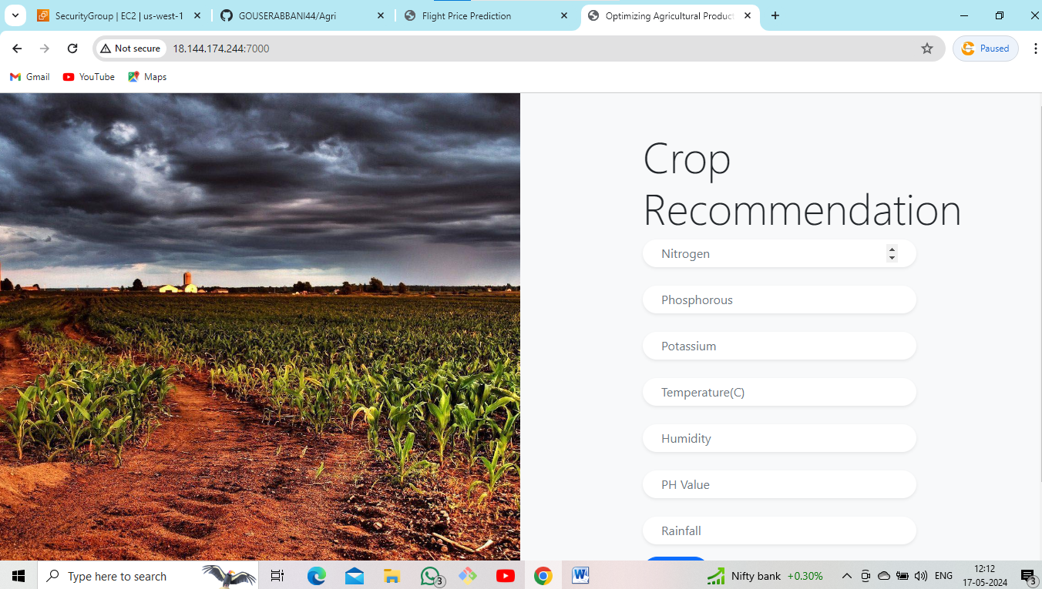

**Step 9: (Fuel-consumption-Rating)**

* Using these command as follows

< sudo git clone (repo name) >

* Change the name

< cd (repo name) >

* Install requirements packages using these command as follows

< pip3 install -r requirements.txt >

* After that change the port number open the file as

< sudo vi app.py >

* Run the server using these command as

< python3 app.py >

* Go to EC2 instance, Edit inbound rules and save it, copy public ip and paste to Google.

< public ip : port number >

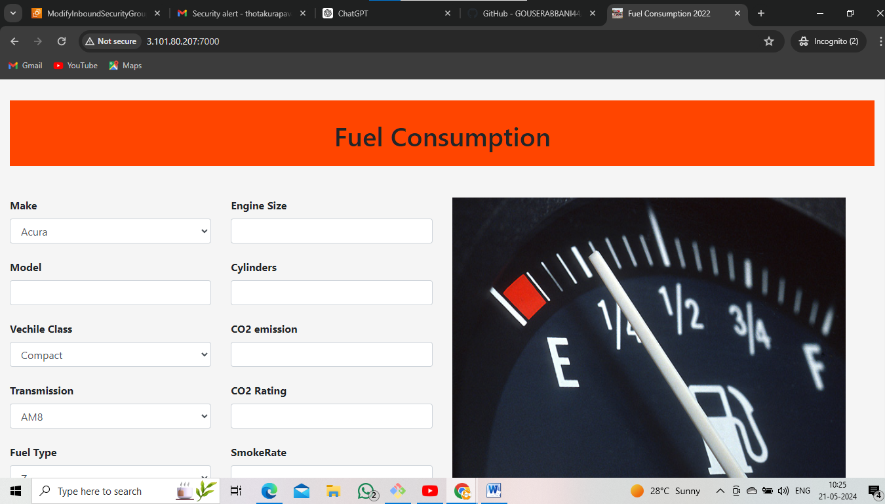

**Step 10: (USA-Housing)**

* Using these command as follows

< sudo git clone (repo name) >

* Change the name

< cd (repo name) >

* Install requirements packages using these command as follows

< pip3 install -r requirements.txt >

* After that change the port number open the file as

< sudo vi app.py >

* Run the server using these command as

< python3 app.py >

* Go to EC2 instance, Edit inbound rules and save it, copy public ip and paste to Google.

< public ip : port number >

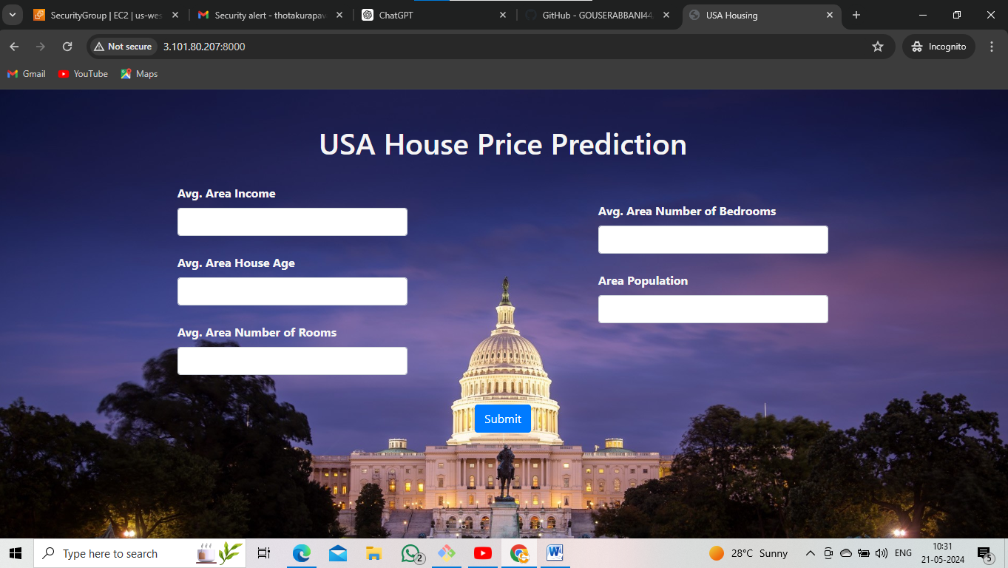

**Step 11: (My Fuel)**

* Using these command as follows

< sudo git clone (repo name) >

* Change the name

< cd (repo name) >

* Install requirements packages using these command as follows

< pip3 install -r requirements.txt >

* After that change the port number open the file as

< sudo vi app.py >

* Run the server using these command as

< python3 app.py >

* Go to EC2 instance, Edit inbound rules and save it, copy public ip and paste to Google.

< public ip : port number >

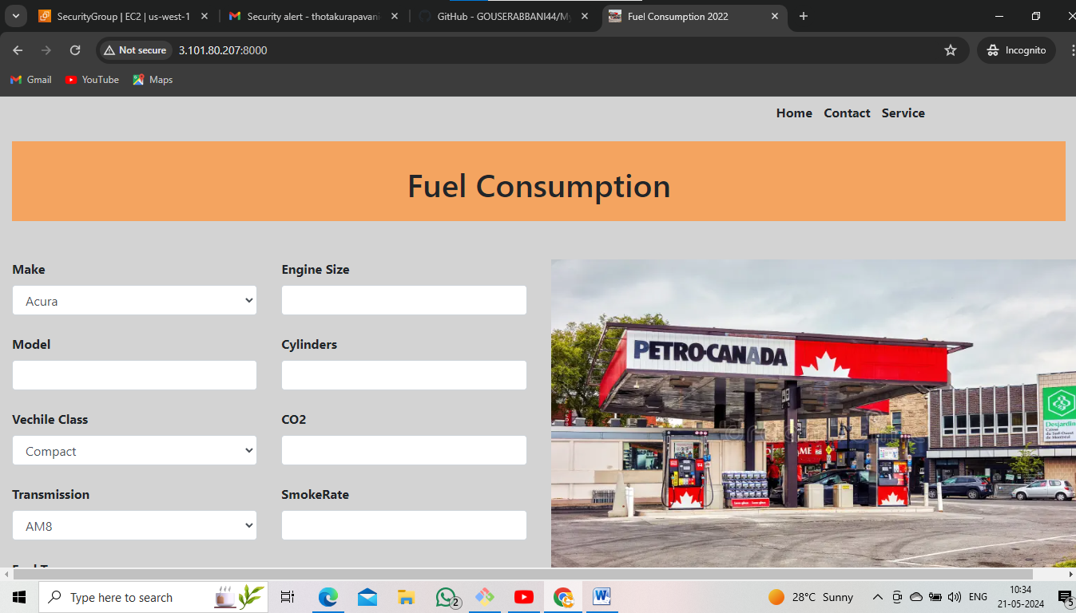

**Step 12: (Indian Liver Patients)**

* Using these command as follows

< sudo git clone (repo name) >

* Change the name

< cd (repo name) >

* Install requirements packages using these command as follows

< pip3 install -r requirements.txt >

* After that change the port number open the file as

< sudo vi app.py >

* Run the server using these command as

< python3 app.py >

* Go to EC2 instance, Edit inbound rules and save it, copy public ip and paste to Google.

< public ip : port number >

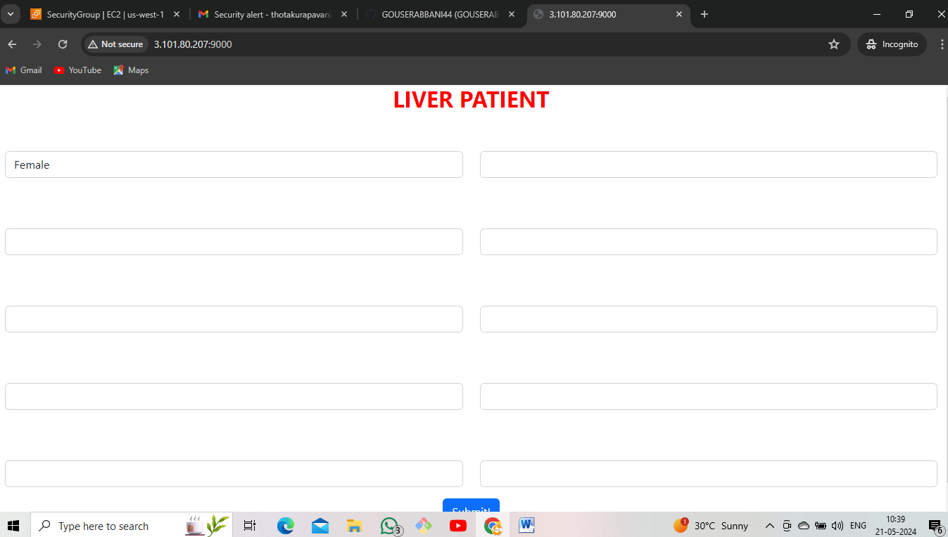

**Step 13: (InNews)**

* Using these command as follows

< sudo git clone (repo name) >

* Change the name

< cd (repo name) >

* Install requirements packages using these command as follows

< pip3 install -r requirements.txt >

* After that change the port number open the file as

< sudo vi app.py >

* Run the server using these command as

< python3 app.py >

* Go to EC2 instance, Edit inbound rules and save it, copy public ip and paste to Google.

< public ip : port number >

* I got error

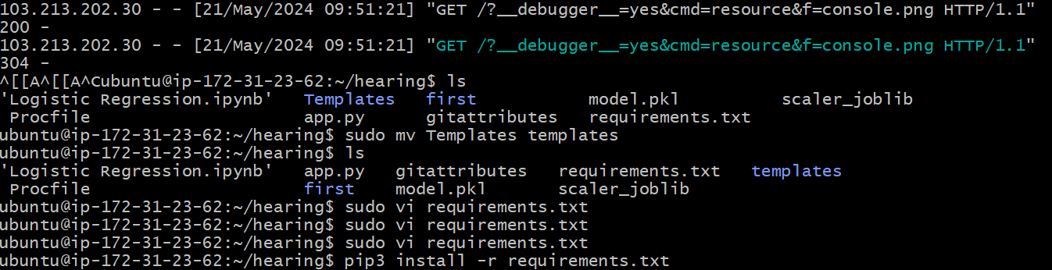

* I am using these command for name changing of Templates to templates.

< sudo mv Templates templates >

* I am using these command for requirements file.

< sudo vi requirements.txt >

* Remove the requirement versions.

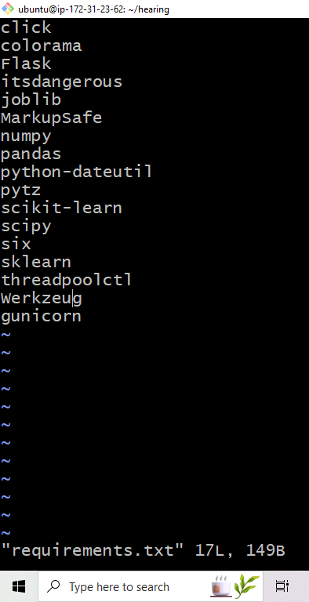

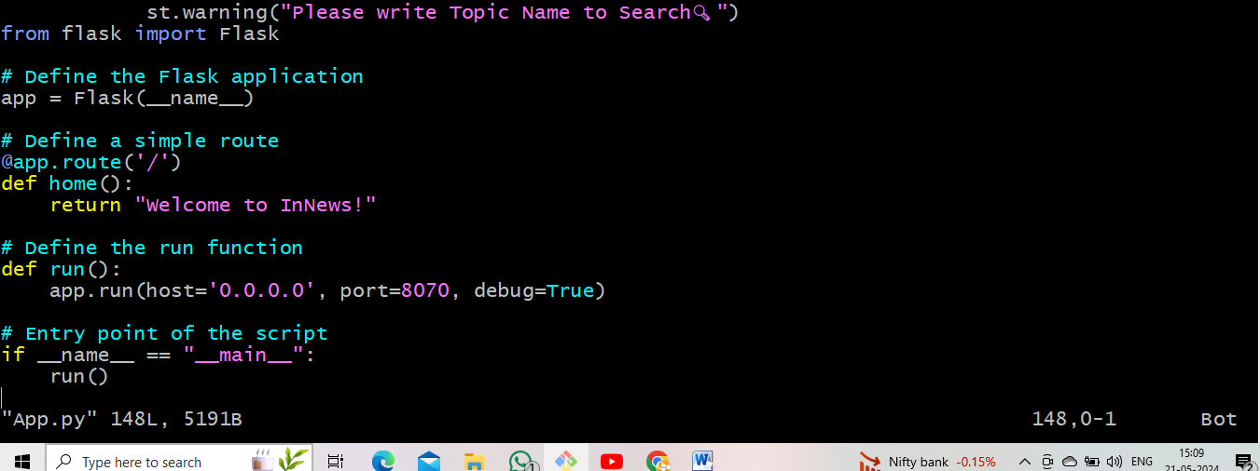

* Go to EC2 instance, Edit inbound rules and save it, copy public ip and paste to Google.

< public ip : port number >

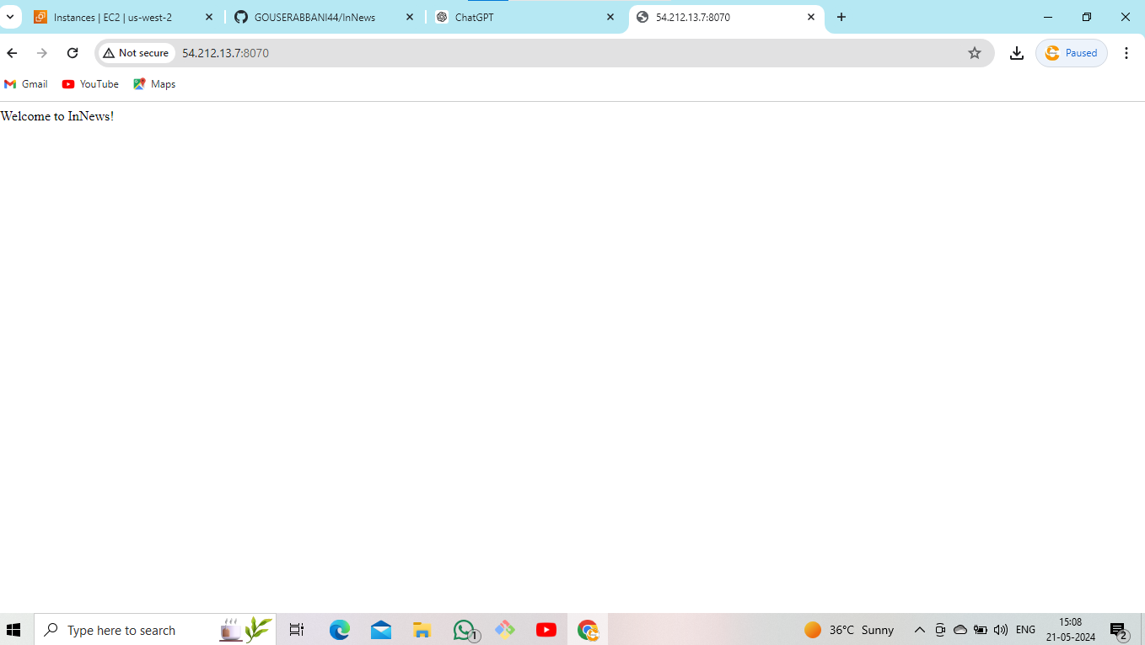

**Step 14: (Hearing)**

* Using these command as follows

< sudo git clone (repo name) >

* Change the name

< cd (repo name) >

* Install requirements packages using these command as follows

< pip3 install -r requirements.txt >

* After that change the port number open the file as

< sudo vi app.py >

* Run the server using these command as

< python3 app.py >

* Go to EC2 instance, Edit inbound rules and save it, copy public ip and paste to Google.

< public ip : port number >

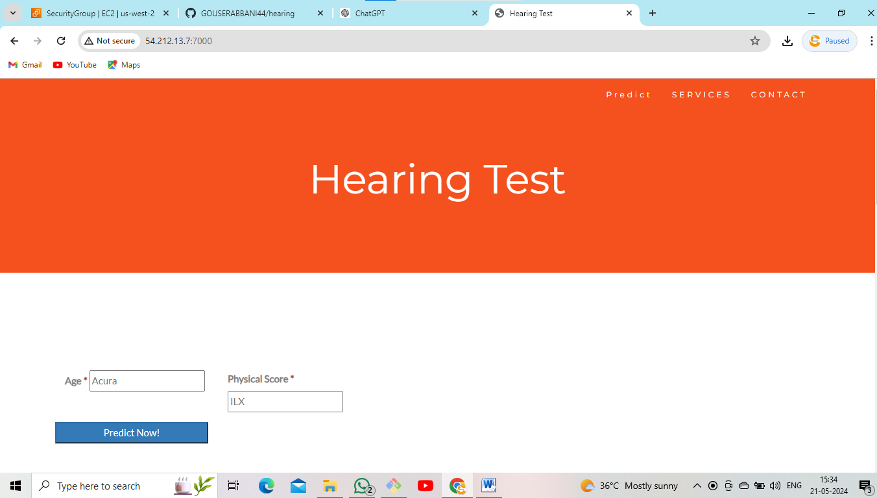

**\*\*\*\*\*\*\*\*\*\*\*\*\*\*\*\*\*\*\*\*\*\*\*\*\*\*\*\*\*\*\*\*\*\*\*\*\***

**2. Build and deploy python applications along with EC2 instance (user data)?**

* Go to EC2 instance.
* Edit inbound rules (HTTP, HTTPS, Allow all traffic).
* Go to advanced details.
* Opened user data. Upload the script here.

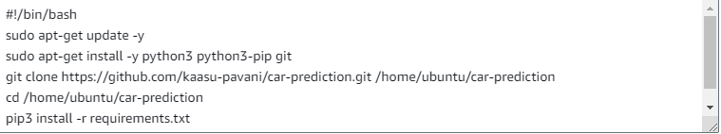

* Launch EC2 instance.

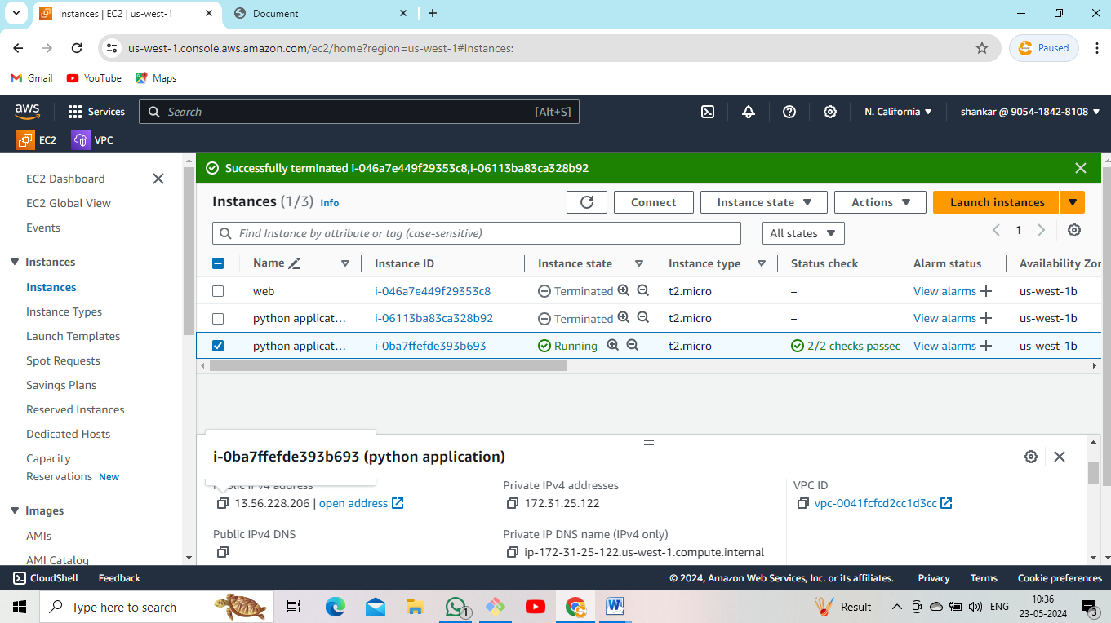

* Copy public ip and paste it google.

< copy public ip : port number >

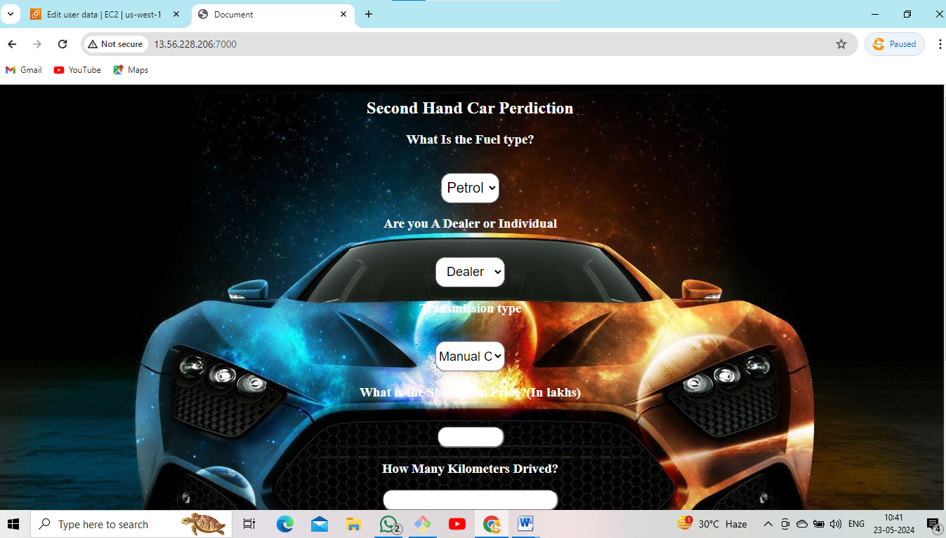

**************************************************

**3. Build and deploy python applications in Bash scripting?**

* Go to EC2 instance.
* Select AMI Ubuntu server.
* Edit inbound rules (HTTP, HTTPS, Allow all traffic).
* Launch EC2 instance.

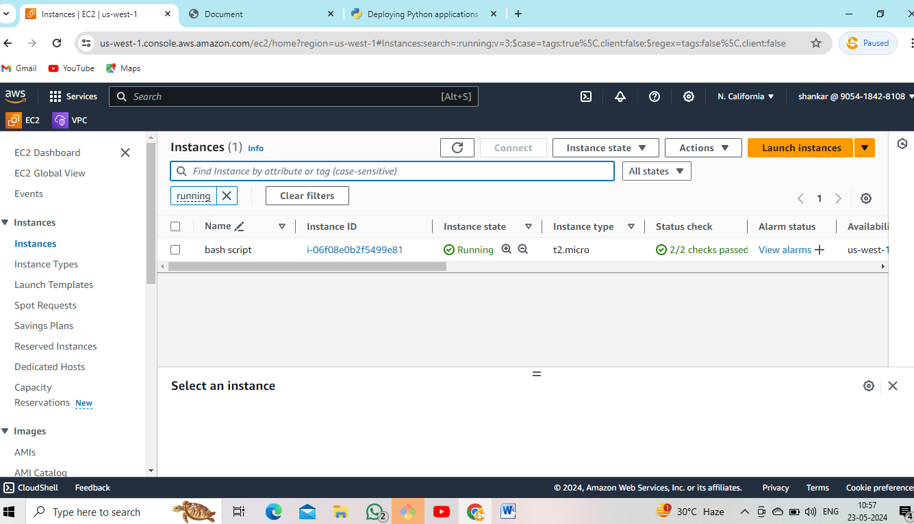

* Go to Git Bash.
* Update Ubuntu machine.

< sudo apt update >

* Full upgrade the machine.

< sudo apt-get full-upgrade –y >

* Install required packages.

< sudo apt-get install python3 pip >

* Created one file and upload the script.

< sudo vi data.sh >

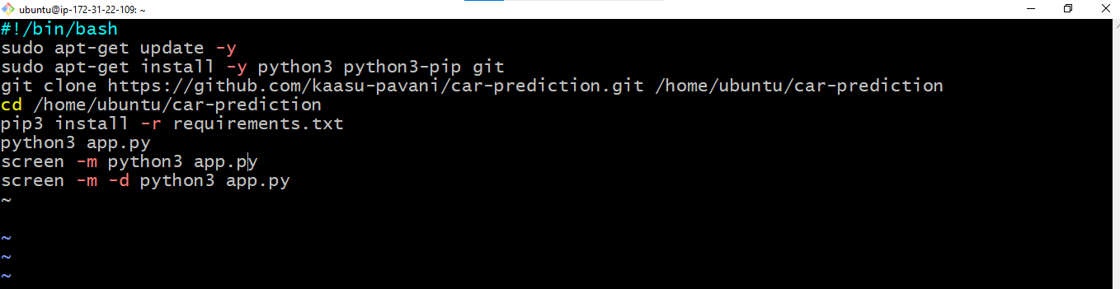

* After that given the permissions.

< sudo chmod +x data.sh >

< ./data.sh >

* Go to EC2 instance copy public ip and paste it Google.

< copy public ip : port number >



**4. Build and deploy python applications with Git, Github and Jenkins (execute shell)?**

* Go to EC2 instance
* Select AMI Ubuntu server.
* Select t3.mediam.
* Edit inbound rules.(HTTP,8080,application port number or all traffic)
* Launch EC2 instance.

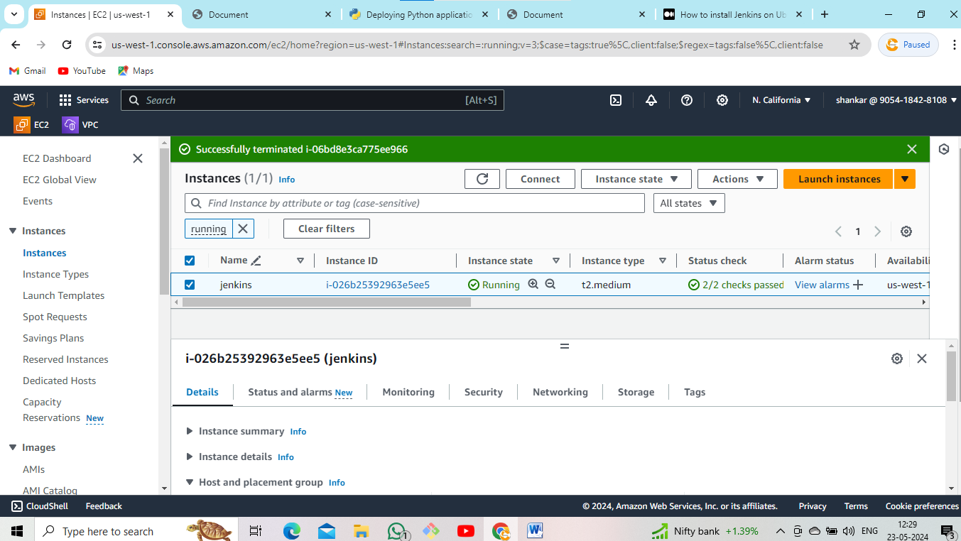

* Go to Git Bash.
* Update the machine.

< sudo apt update >

* After that install git using these command following below.

< sudo yum install git –y >

* Install java for using these command below

< >

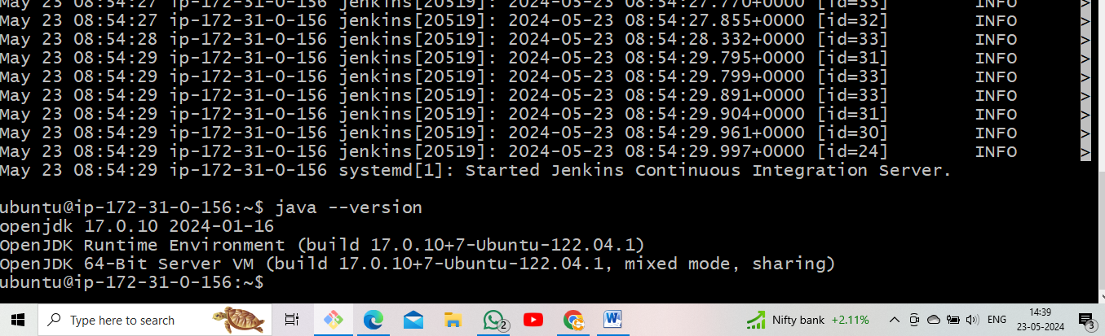

* After that install Jenkins using these commands as below
* Go to Google, search install Jenkins in Ubuntu server.
* sudo wget -O /usr/share/keyrings/jenkins-keyring.asc \<https://pkg.jenkins.io/debian-stable/jenkins.io-> 2023.key
* echo "deb [signed-by=/usr/share/keyrings/jenkins-keyring.asc]"\https://pkg.jenkins.io/debian-stable binary/ | sudo tee \/etc/apt/sources.list.d/jenkins.list > /dev/null
* sudo apt-get update
* sudo apt-get install jenkins
* after that start jenkins for using these commands as below

< sudo systemctl start jenkins >

< sudo systemctl enable jenkins >

< sudo systemctl status jenkins >

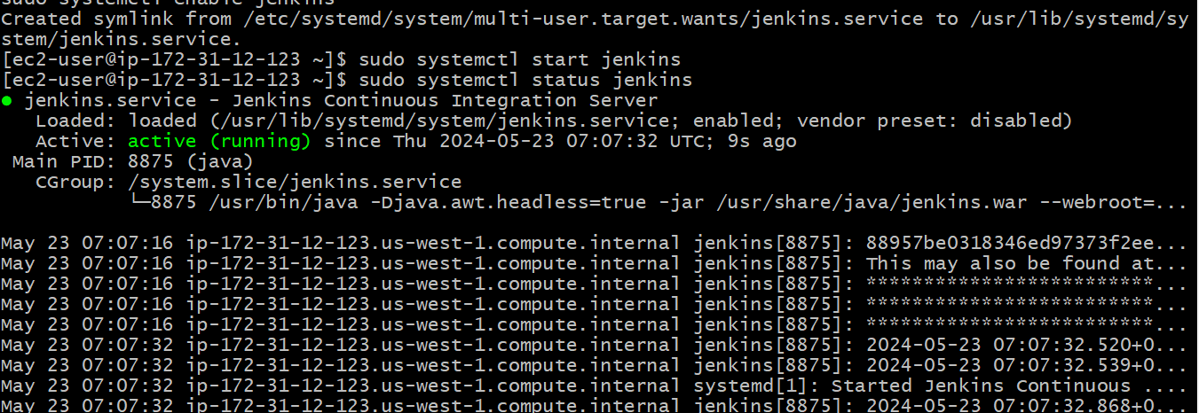

* After that go to EC2 instance copy public ip and jenkins port number paste it Google.

< copy public ip : 8080 >

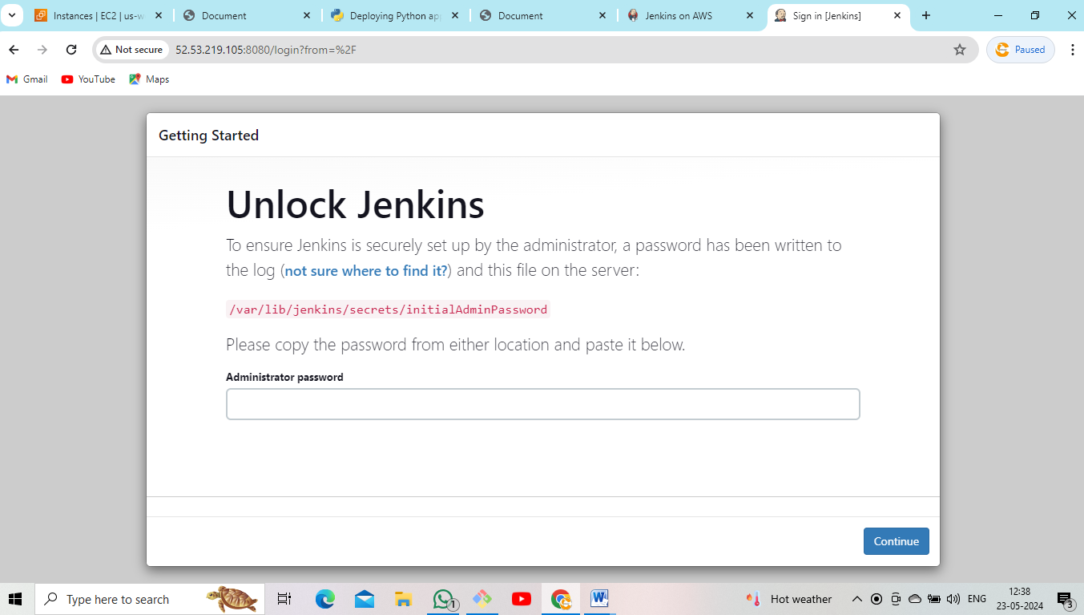

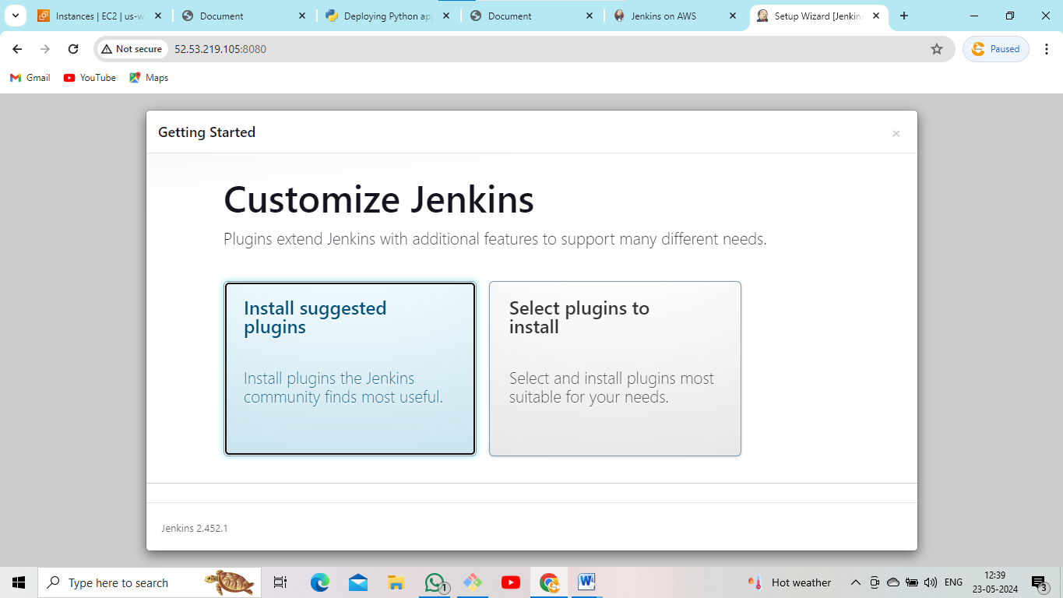

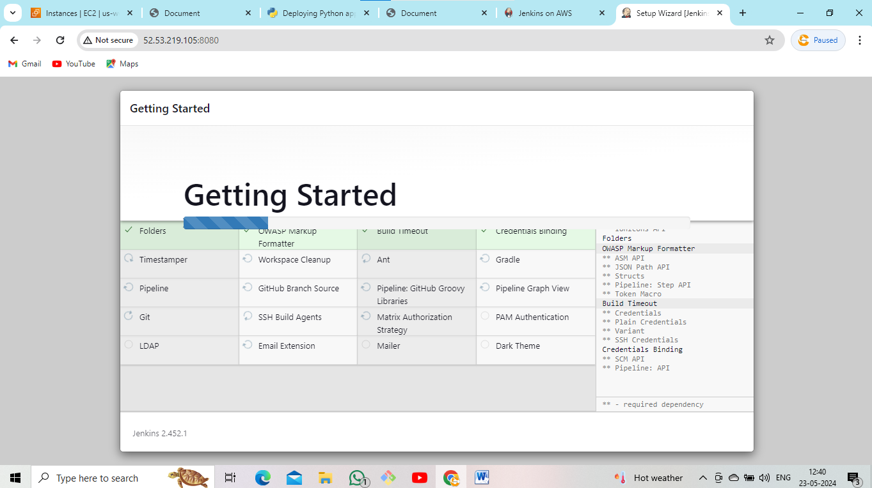

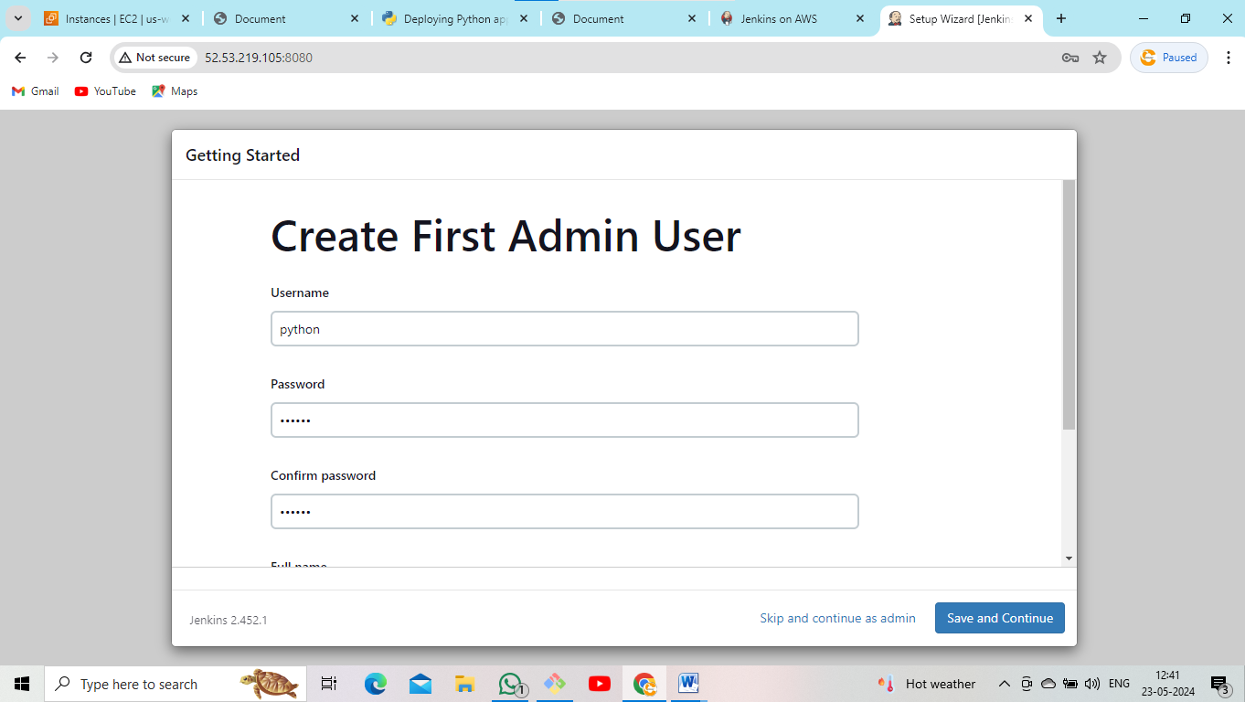

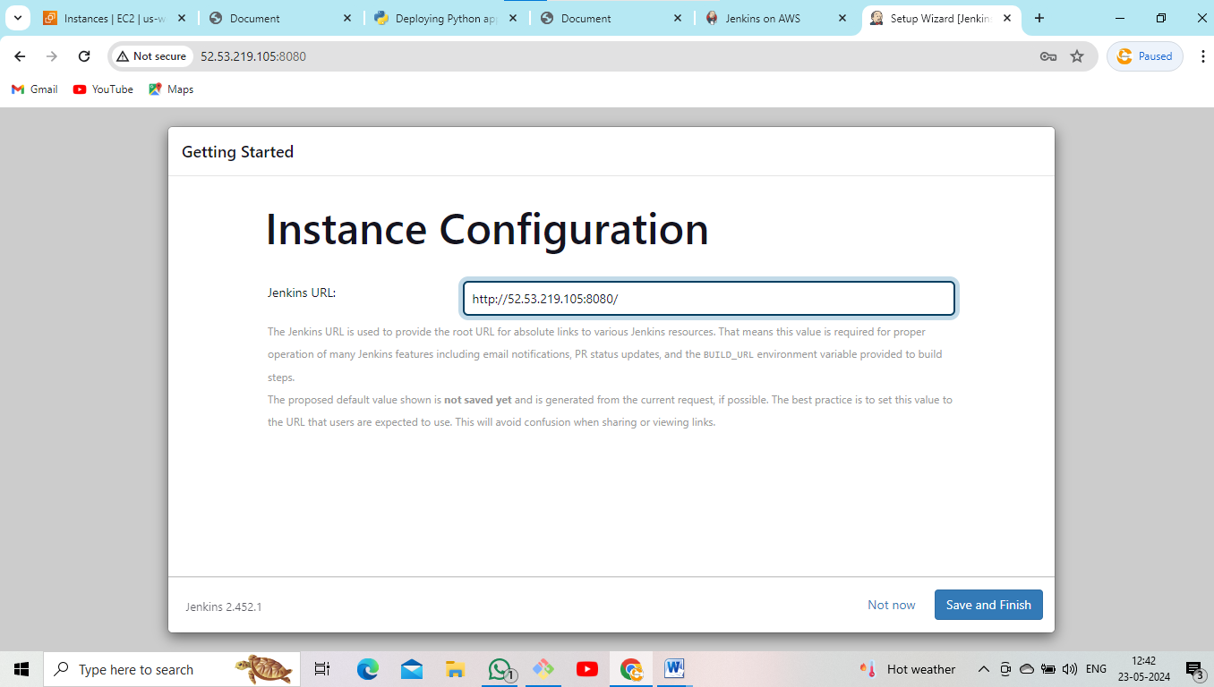

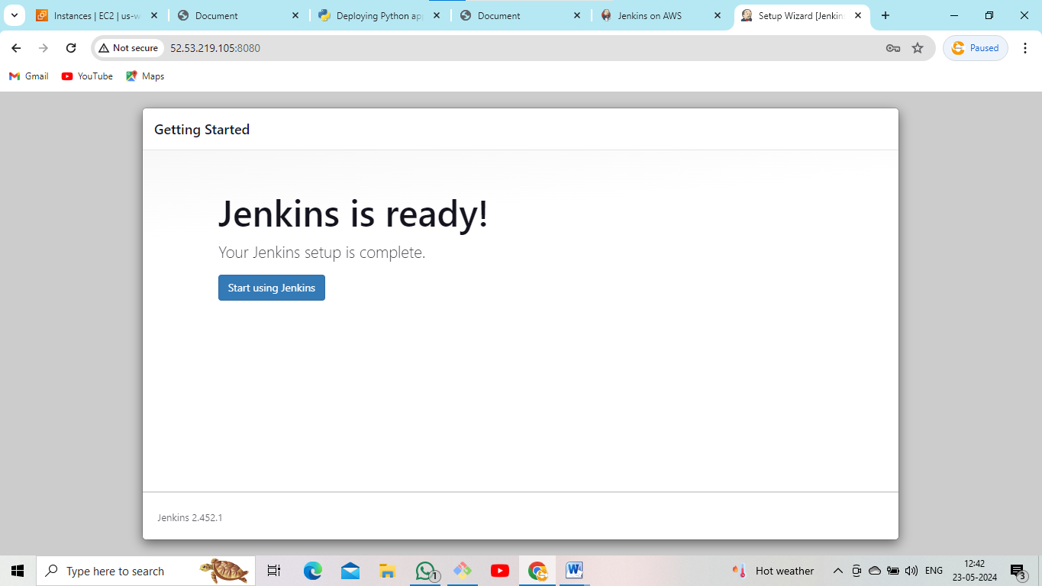

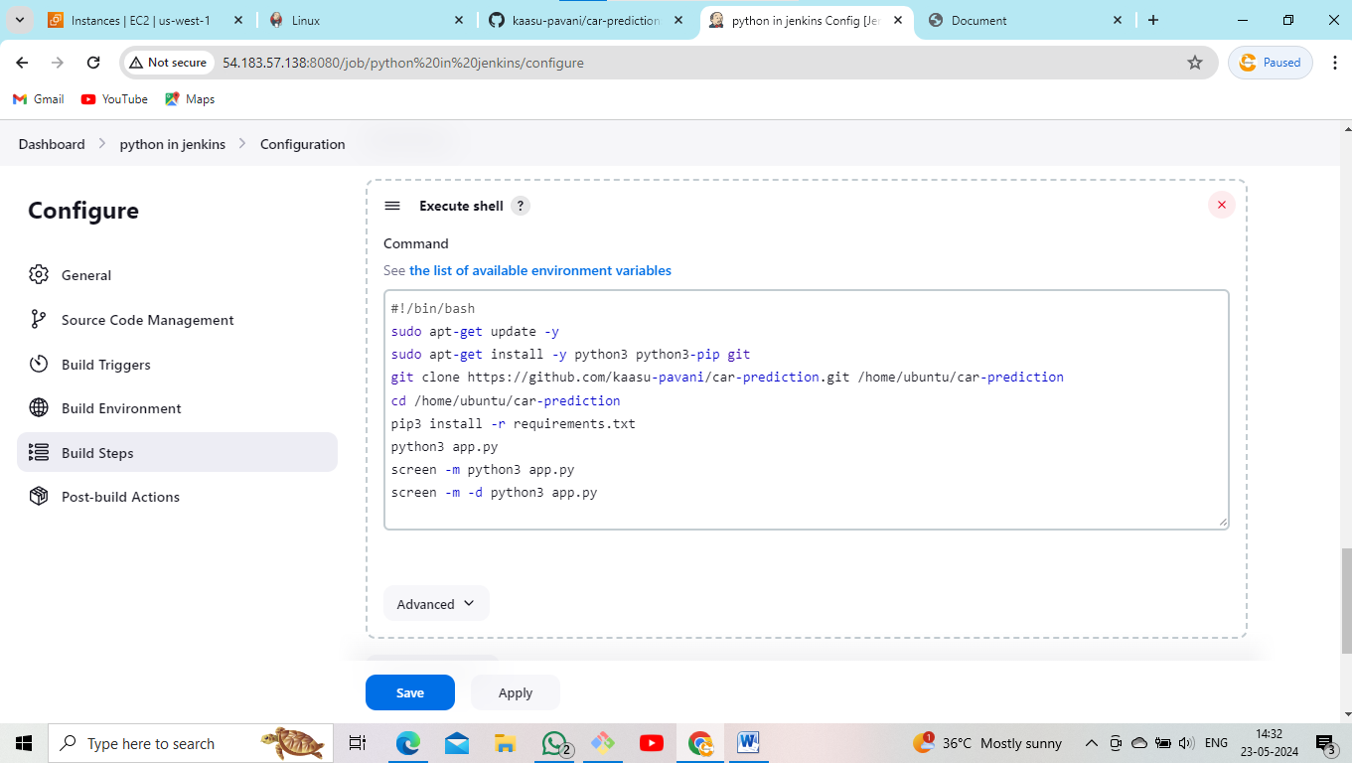

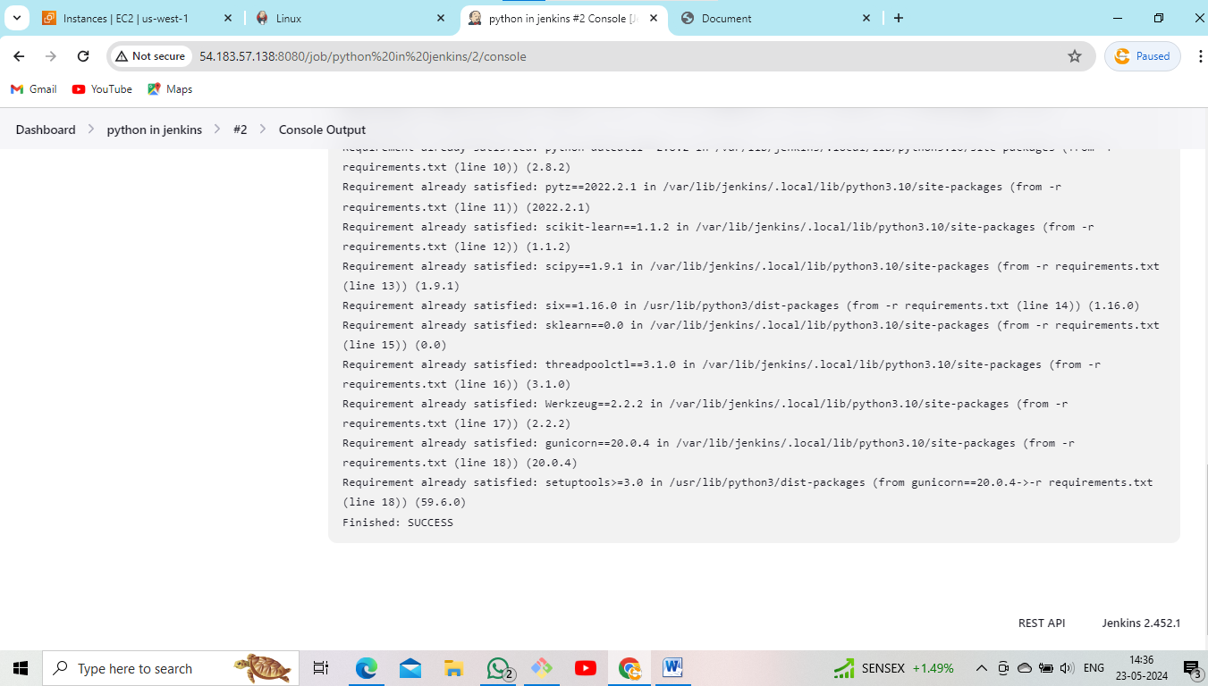

* Go to EC2 instance copy public ip and application port number paste it Google.



*************************************************

**5. Build and deploy python applications with the Terraform (data.sh) and push the Terraform Scripted files in Github?**

* Go to EC2 instance.
* Select AMI Ubuntu server.
* Select t2.micro.
* Edit inbound rules.
* Launch EC2 instance.

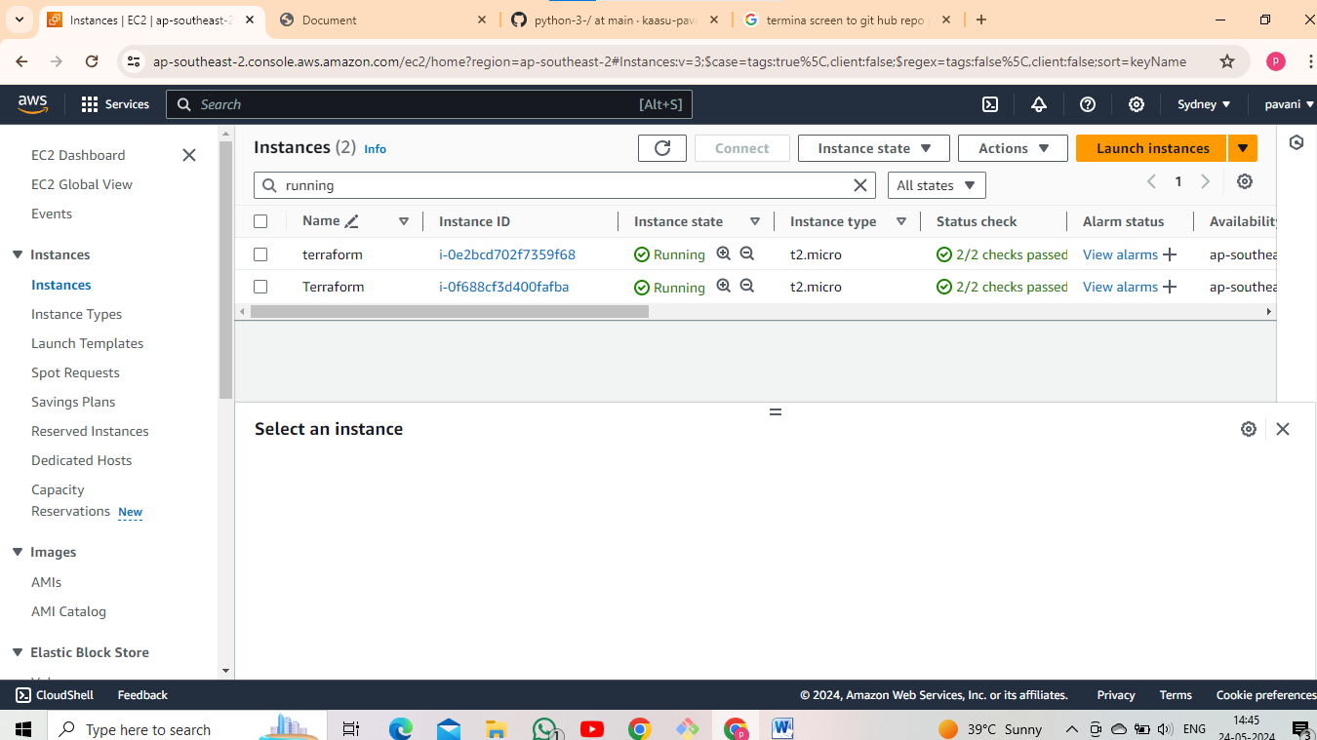

* Go to Git Bash.
* Update Ubuntu machine.

< sudo apt update >

* Full upgrade the machine.

< sudo apt-get full-upgrade –y >

* Install terraform using these commands as
* wget -O- https://apt.releases.hashicorp.com/gpg | sudo gpg --dearmor -o/usr/share/keyrings/hashicorp-archive-keyring.gpg

echo "deb [signed-by=/usr/share/keyrings/hashicorp- archive-keyring.gpg] https://apt.releases.hashicorp.com $(lsb_release -cs) main" | sudo tee /etc/apt/sources.list.d/hashicorp.list

sudo apt update && sudo apt install terraform

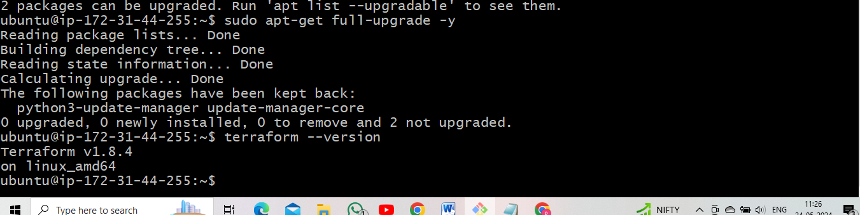

* After that create two files. one is data.sh and second one is main.tf.

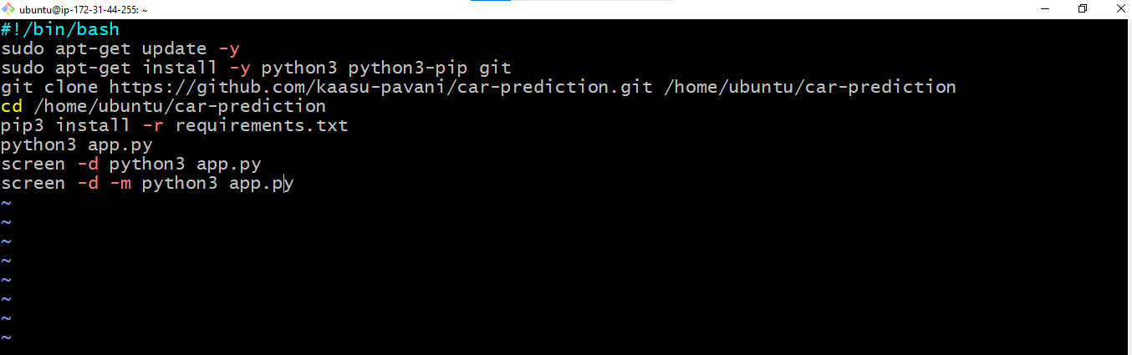

* Above screen is data.sh.
* After that create main.tf file.

provider "aws" {

region = "ap-northeast-3"

}

# Defining CIDR Block for VPC

variable "vpc_cidr" {

default = "10.0.0.0/16"

}

# Defining CIDR Block for Subnet

variable "subnet_cidr" {

default = "10.0.1.0/24"

}

# Creating the VPC

resource "aws_vpc" "main" {

cidr_block = var.vpc_cidr

instance_tenancy = "default"

tags = {

Name = "vpc"

}

}

# Creating the Subnet

resource "aws_subnet" "main" {

vpc_id = aws_vpc.main.id

cidr_block = var.subnet_cidr

availability_zone = "ap-northeast-3a"

tags = {

Name = "subnet"

}

}

# Creating the Internet Gateway

resource "aws_internet_gateway" "main" {

vpc_id = aws_vpc.main.id

}

# Creating the Route Table

resource "aws_route_table" "main" {

vpc_id = aws_vpc.main.id

route {

cidr_block = "0.0.0.0/0"

gateway_id = aws_internet_gateway.main.id

}

tags = {

Name = "Route to internet"

}

}

# Associating Route Table with Subnet

resource "aws_route_table_association" "subnet_assoc" {

subnet_id = aws_subnet.main.id

route_table_id = aws_route_table.main.id

}

# Creating Security Group

resource "aws_security_group" "py_sg" {

vpc_id = aws_vpc.main.id

# Inbound Rules

ingress {

from_port = 80

to_port = 80

protocol = "tcp"

cidr_blocks = ["0.0.0.0/0"]

}

ingress {

from_port = 7000

to_port = 7000

protocol = "tcp"

cidr_blocks = ["0.0.0.0/0"]

}

ingress {

from_port = 443

to_port = 443

protocol = "tcp"

cidr_blocks = ["0.0.0.0/0"]

}

ingress {

from_port = 22

to_port = 22

protocol = "tcp"

cidr_blocks = ["0.0.0.0/0"]

}

# Outbound Rules

egress {

from_port = 0

to_port = 0

protocol = "-1"

cidr_blocks = ["0.0.0.0/0"]

}

tags = {

Name = "Web SG"

}

}

# Creating EC2 Instance

resource "aws_instance" "Terraform" {

ami = "ami-058a260ffc06d25e2"

instance_type = "t2.micro"

key_name = "hm"

vpc_security_group_id = [aws_security_group.py_sg.id]

subnet_id = aws_subnet.main.id

associate_public_ip_address = true

user_data = file ("userdata.sh")

tags = {

Name = "Terraform"

}

}

# Output the public IP of the instance

output "public_ip" {

value = aws_instance.Terraform.public_ip

}

# Variable for AWS region

variable "region" {

default = "ap-northeast-3"

}

* After that apply the terraform commands.
* Terraform init
* Terraform fmt
* Terraform validate
* Terraform plan
* Terraform apply

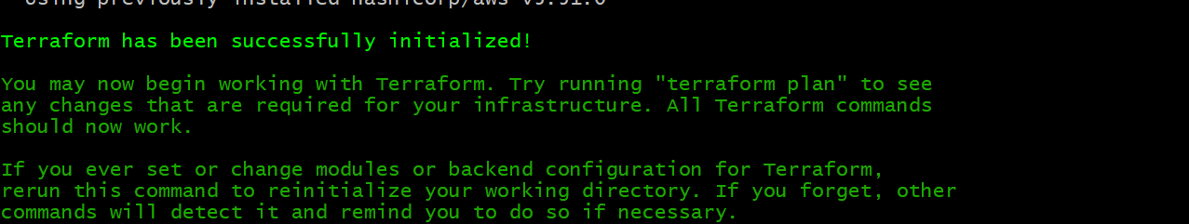

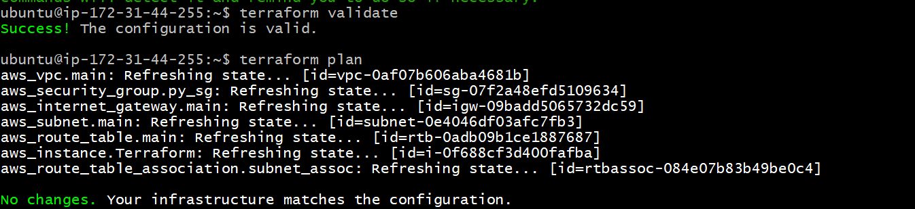

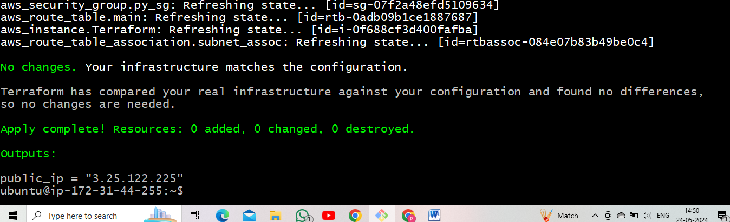

* After that copy public ip and application port number paste it Google.

< copy public ip : port number >

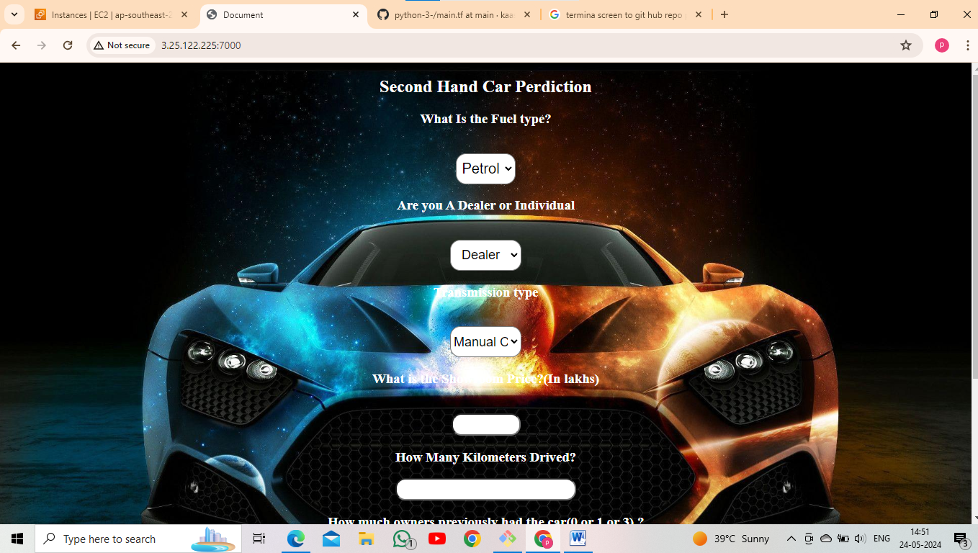

***********************************************

**6. Build and deploy python applications with Git, github, Jenkins and Terraform?**

* Go to EC2 instance.
* Select AMI Ubuntu server.
* Select t3.medium.
* Edit inbound rules.
* Launch EC2 instance.

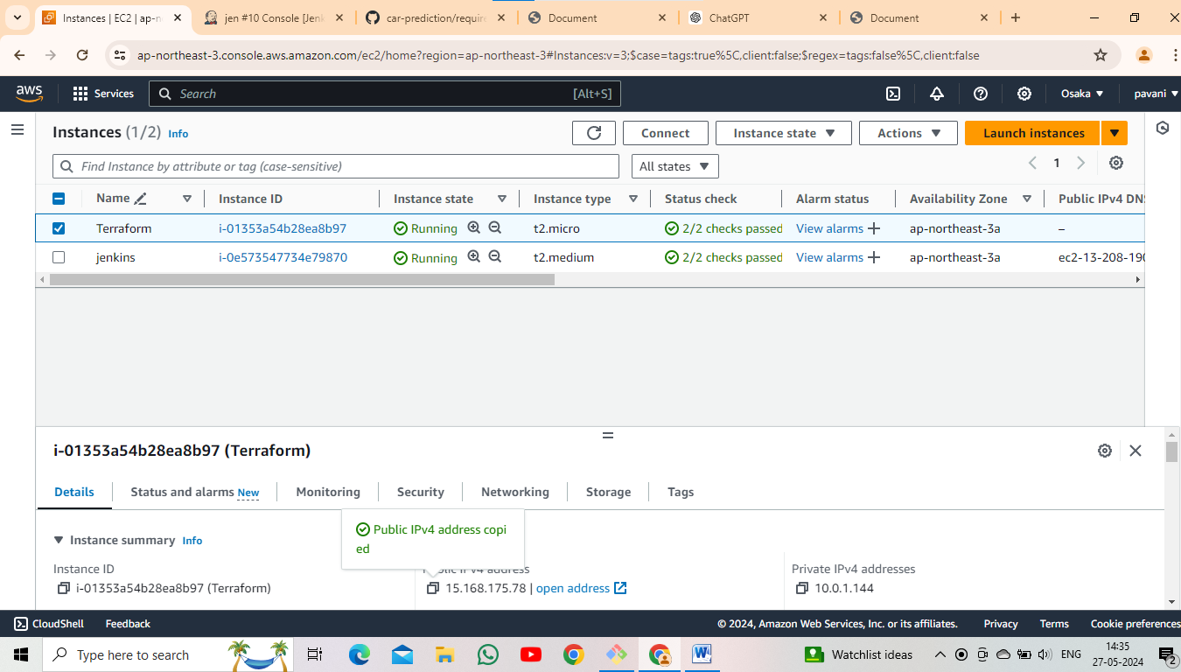

* Go to Git Bash.
* Update the machine.

< sudo yum update >

* After that install java.

< sudo yum –y install java* >

* Install Jenkins.

NOTE: Jenkins installation is above steps (4th step).

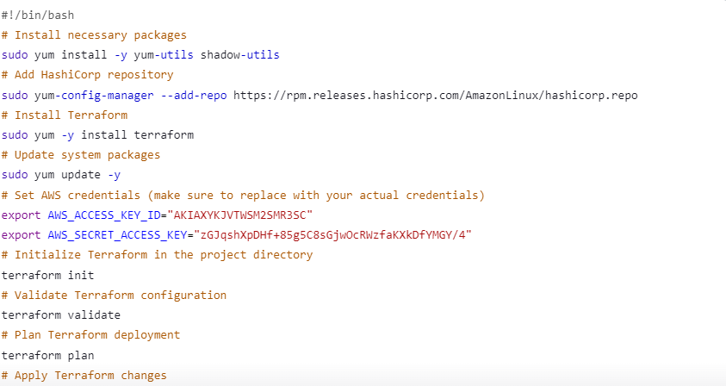

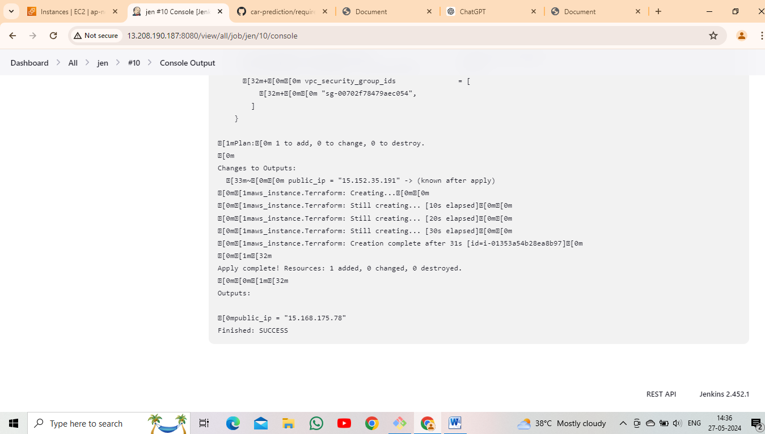

* Go to EC2 instance copy public ip and application port number paste it Google.

< copy public ip : port number >

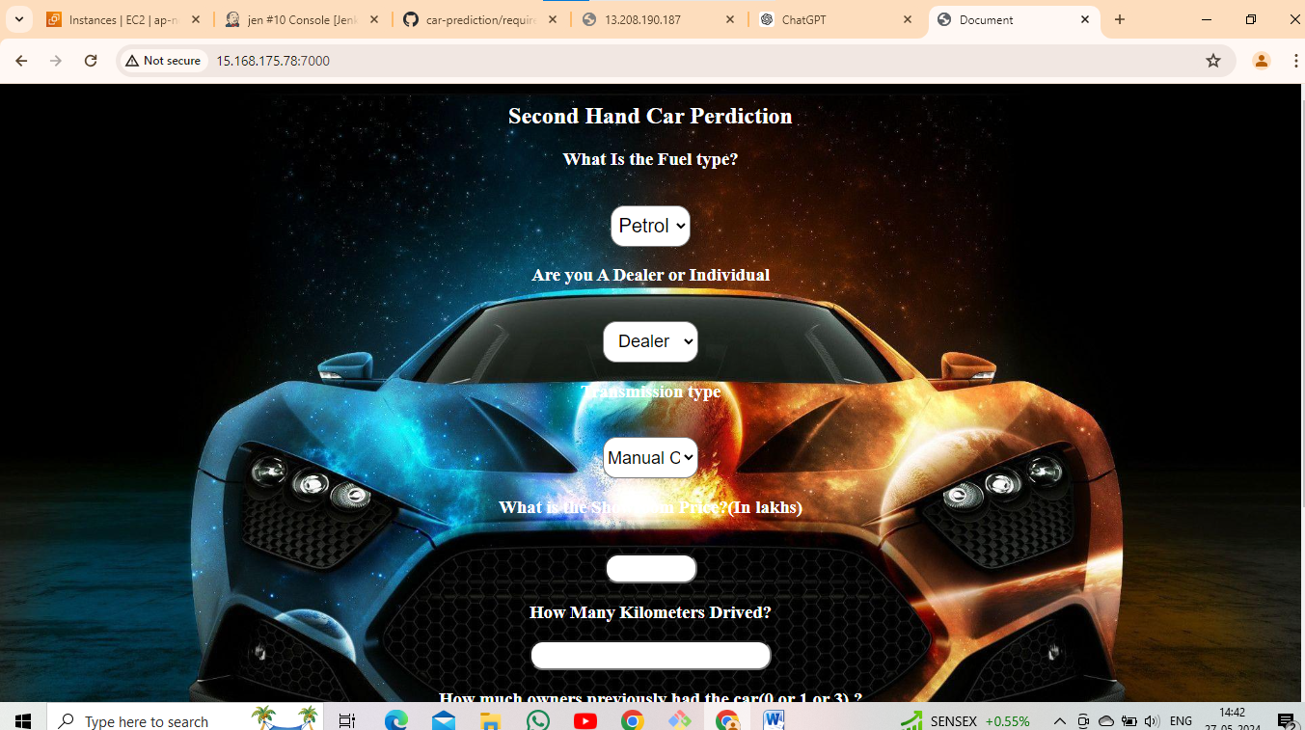

**************************************************

**7. Build and deploy python applications with Docker (Write docker file and create image from docker file and run containers) and push created docker image in docker hub?**

* Go to EC2 instance.
* Select AMI linux.
* Edit inbound rules
* Launch EC2 instance.

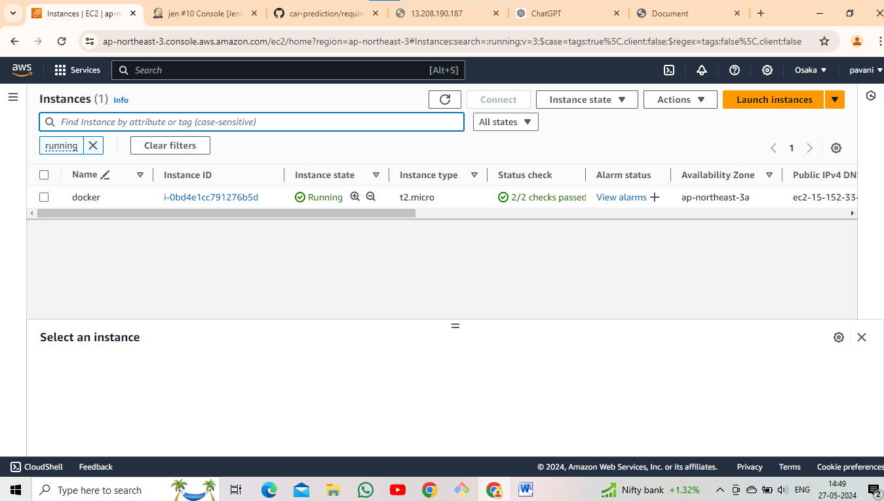

* Go to Git Bash.
* Update the machine using these following command as

< sudo yum update >

* Install docker using these command as

< sudo yum –y install docker >

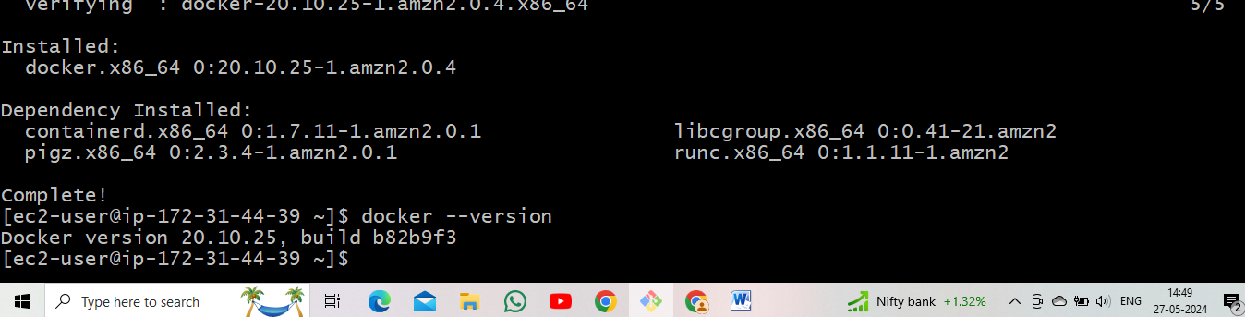

* Docker enable, start, status using these commands as

< sudo systemctl start docker >

< sudo systemctl enable docker >

< sudo systemctl status docker >

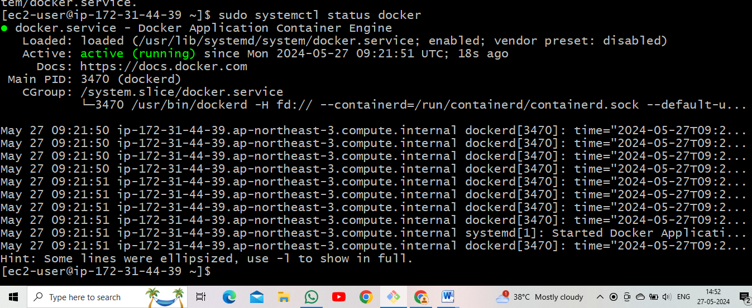

* Install docker-compose file
* Create file using these command as

< vi Dockerfile >

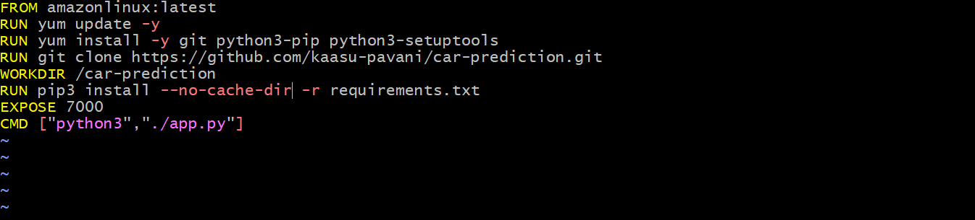

* Give the sudo permissions

< sudo chmod 666 /var/run/docker.sock >

* Docker build using these command as

< sudo docker build –t kasuu20/ car-prediction –app . >

* Docker push using these command as

< sudo docker push kasuu20/ car-prediction >

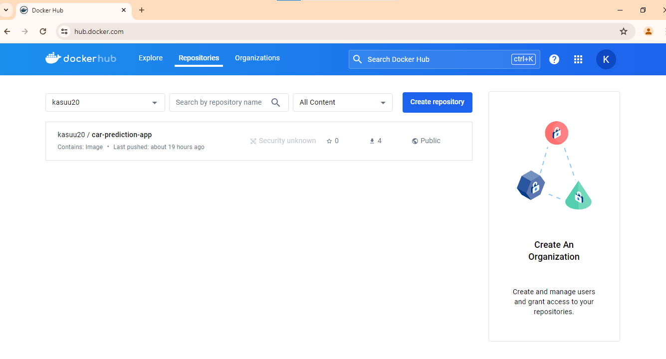

**********************************************

**8. Build and deploy python applications with Docker and k8's (EKS and KOPS) (use Declarative manifest method along with docker image)?**

* Go to EC2 instance.
* Select AMI linux.
* Select t3.medium.
* Edit inbound rules.
* Launch EC2 instance.

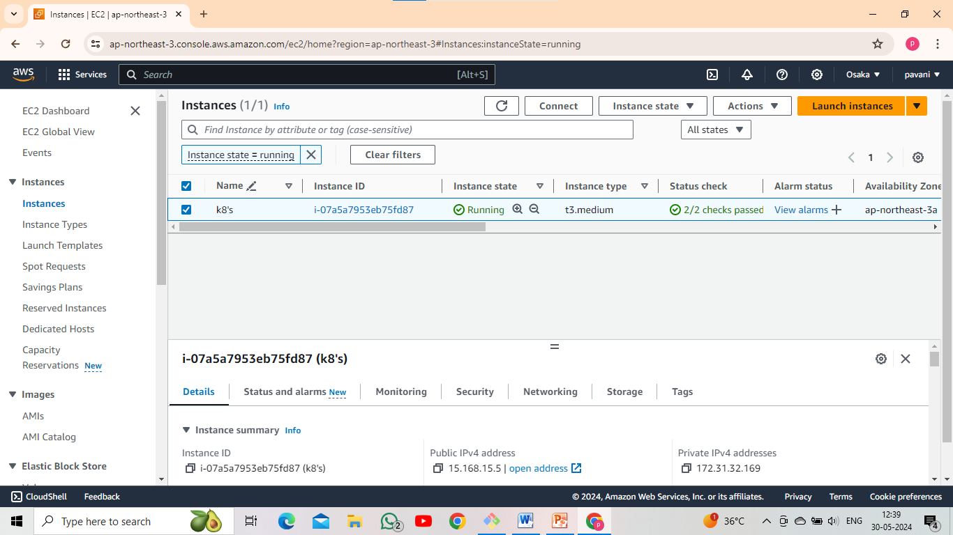

* Go to Git Bash.
* Install kops. (kops commands search for Google)

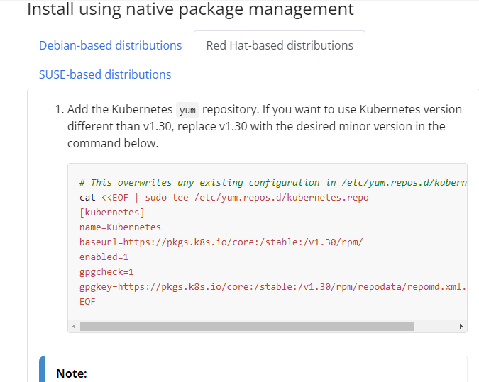

* After that install kubectl using these command as

< sudo yum install –y kubectl >

* Check the kubectl using these command as

< kubectl version --client>

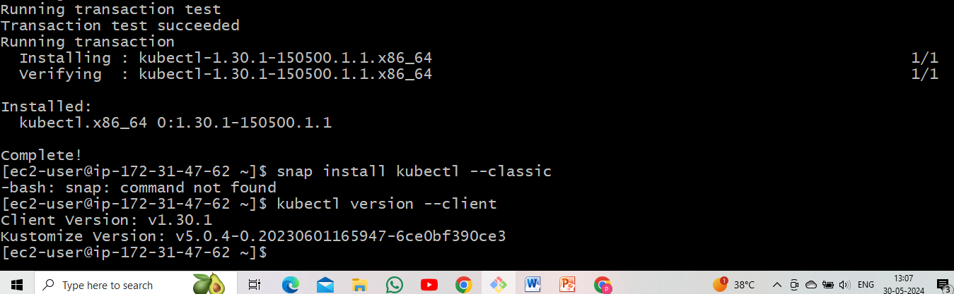

* After that install kops.

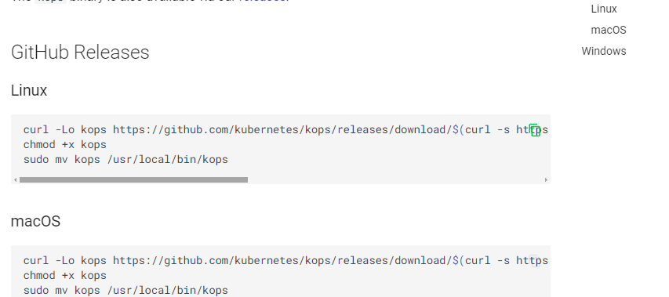

* Create two files.

1.Deployment.yaml

2.service.yaml

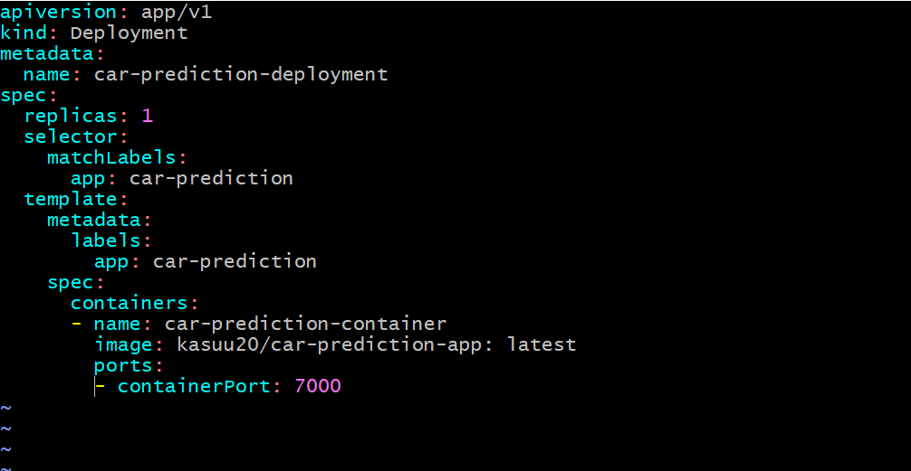

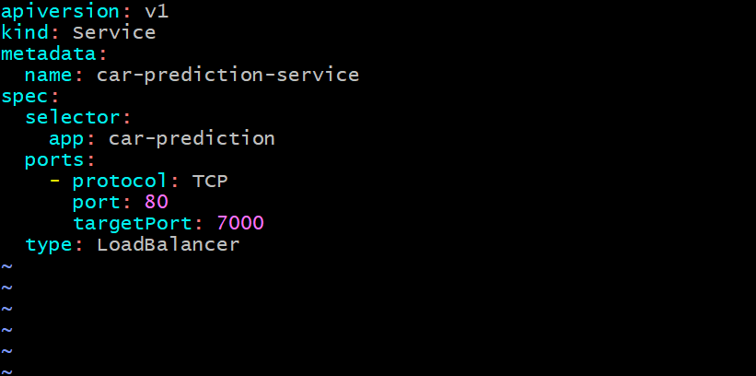

* Create s3 bucket
* Add IAM role in to EC2 instance.
* Create cluster using these command as

< kops create cluster pavani.local –state s3://lucky2024 –zones us-northeast-1a,northeast-1b –node-count 2 --yes >

* validate cluster using these command as

< kops validate cluster >

* kubectl apply the command as

< kubectl apply –f deployment.yaml >

< kubectl apply –f service.yaml >

* After that kubectl delete deployment.yaml, service.yaml & cluster.

*********************************************

**9. Build and deploy python applications with the Git, github, Jenkins and Terraform (with Build periodically, pollscm and webhooks)?**

* Go to EC2 instance.
* Select AMI linux.
* Edit inbound rules.
* Launch EC2 instance.

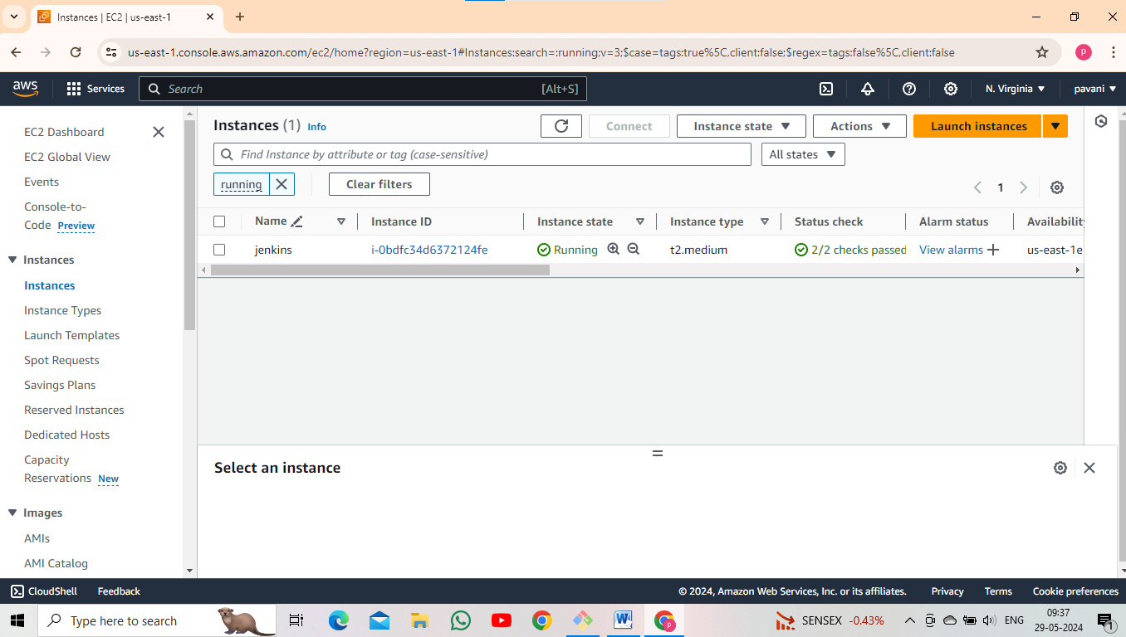

* Add the IAM role into the created EC2 instance.
* Go to Git Bash.
* Update the machine using these following command

< sudo yum update >

* Install git.

< sudo yum –y install git >

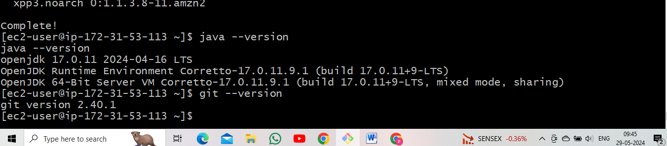

* Install java.

< sudo yum –y install java* >

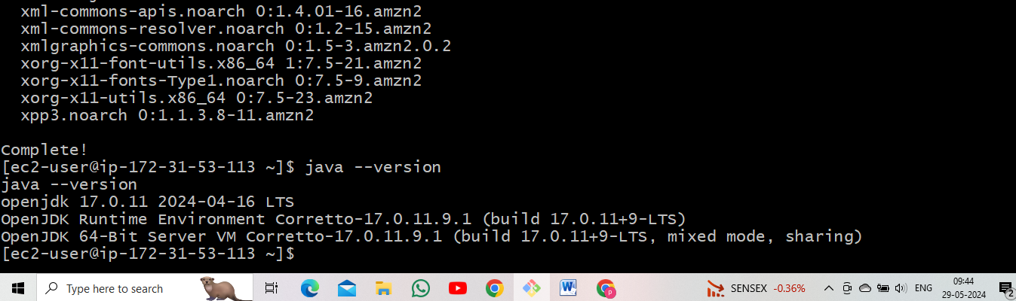

* Install Jenkins.

NOTE: Jenkins installation is above steps (4th step)

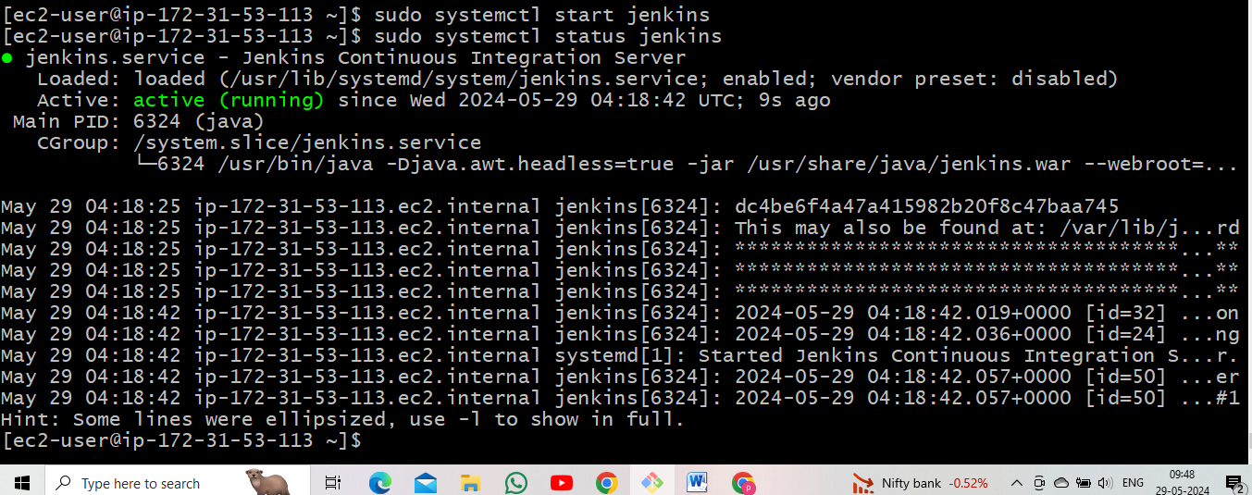

* Give sudo permissions for the Jenkins.

< sudo visudo >

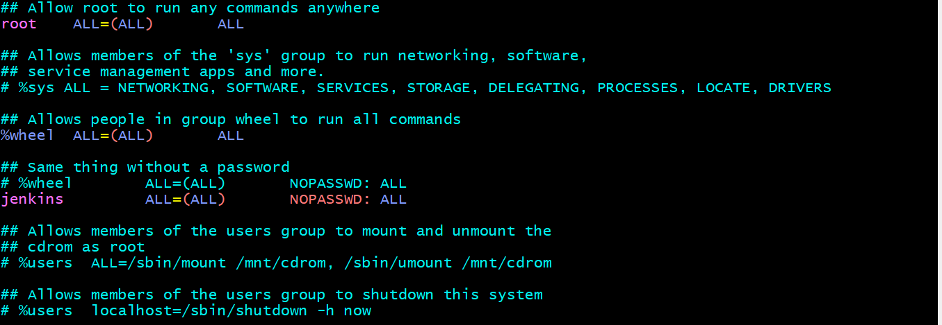

* Go to Jenkins page.
* Create job.

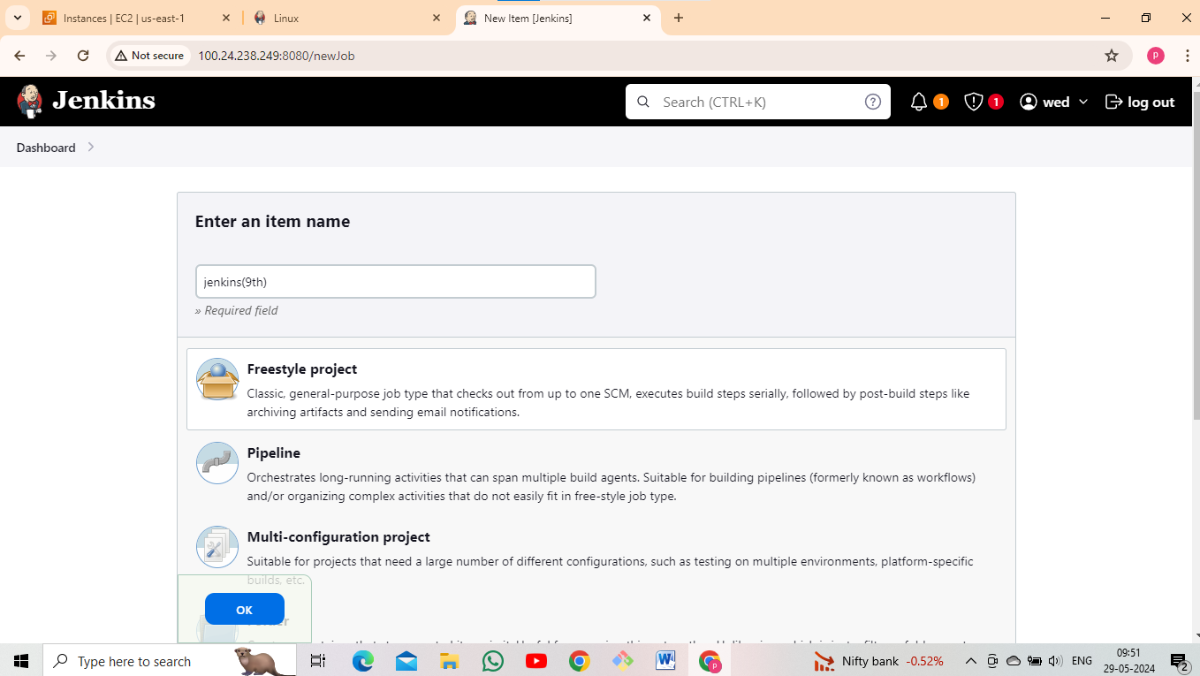

* Give the Git Hub URL.
* After that select Build periodically and poll SCM. give the */2 * * * *(crown syntax).

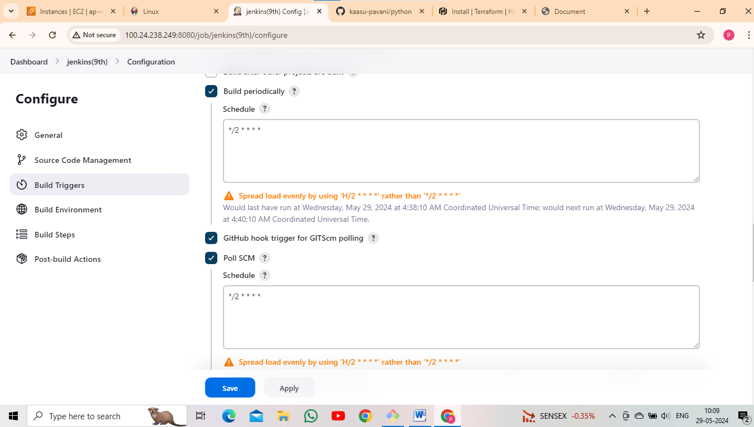

* After that select execute shell and give the terraform installation and terraform execution commands.

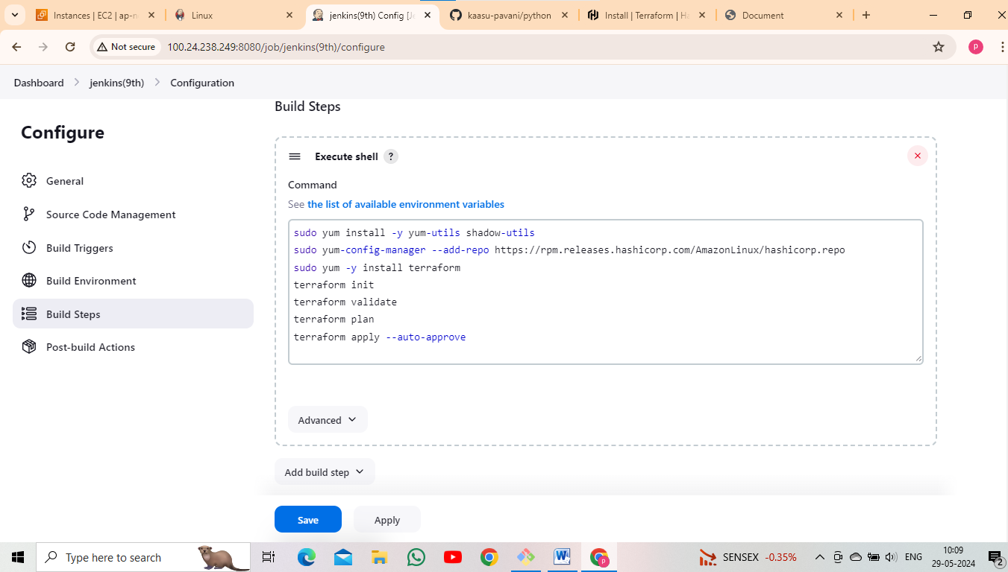

* After that click the apply and save and Build now.

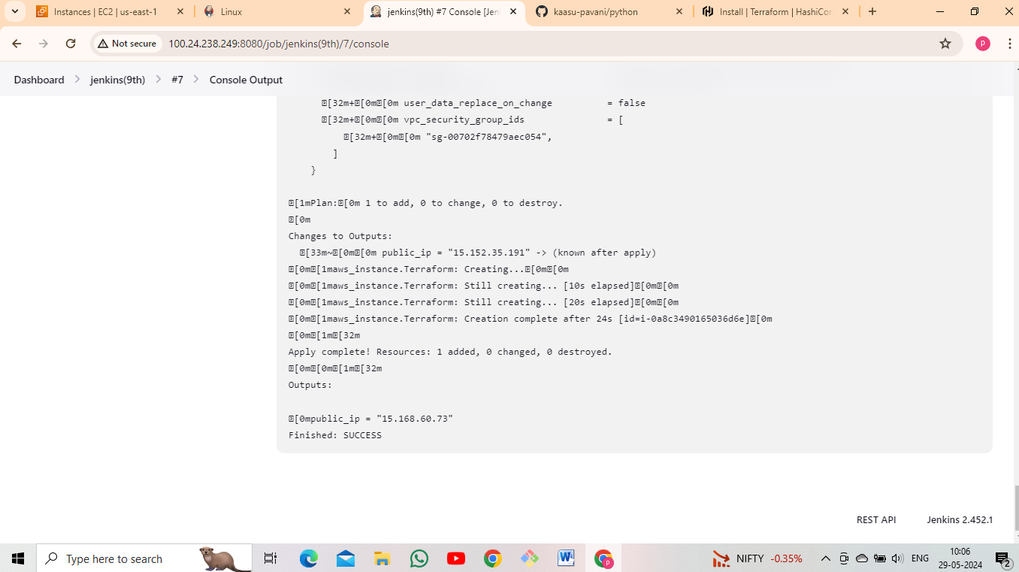

* Now go to EC2 instance. check the instance, terraform instance is created.

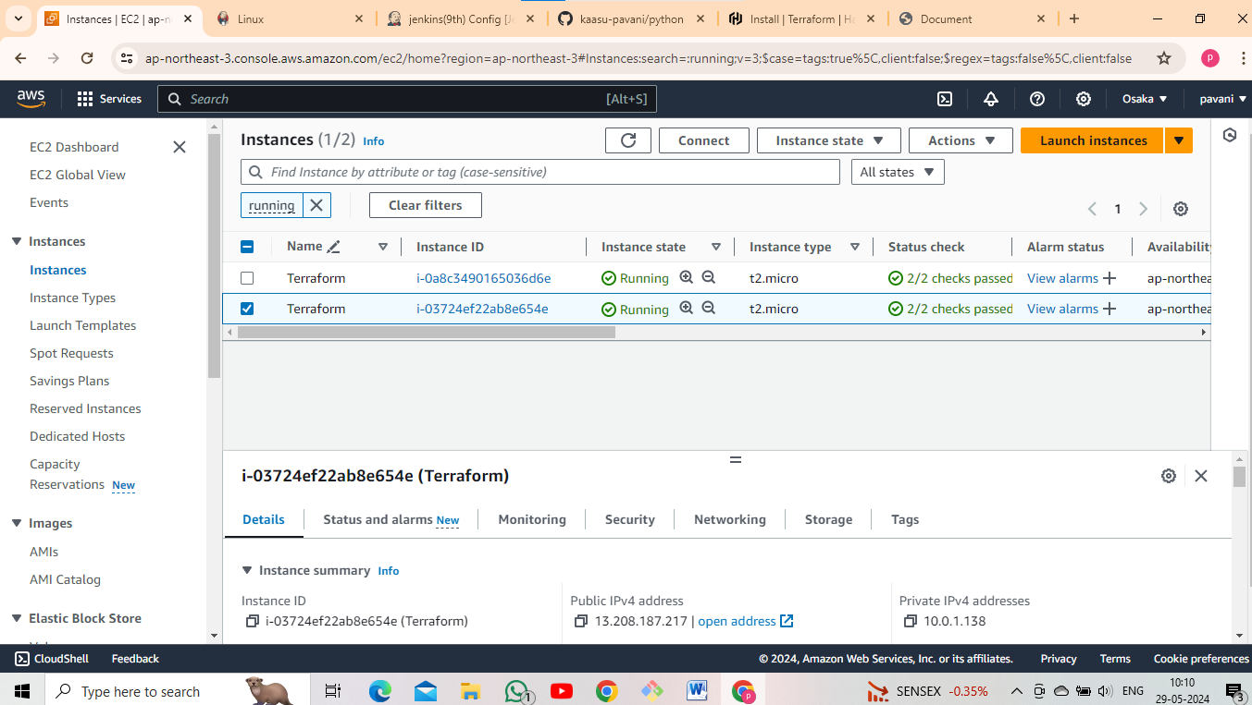

* After that copy public ip and paste it Google.

< copy public ip : application port number >



**********************************************

**10. Build and deploy python applications with pipeline method (create clone job and Build job) with Build periodically, pollscm and webhooks?**

* Go to EC2 instance.
* Select AMI linux.
* Select t3.medium.
* Edit inbound rules.
* Launch EC2 instance.

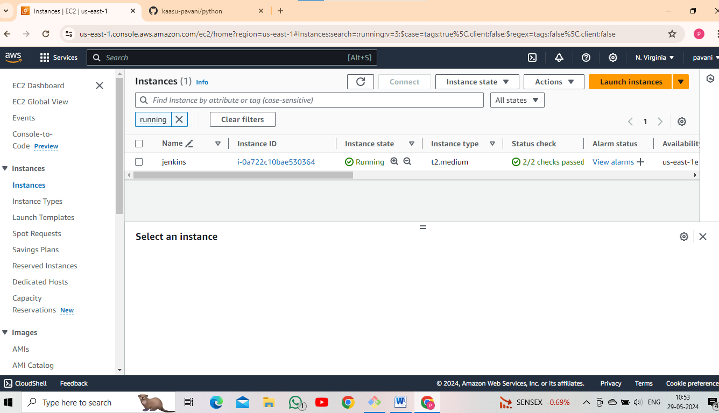

* Go to Git Bash.
* Update the machine using these following command.

< sudo yum update >

* Install git.

< sudo yum –y install git >

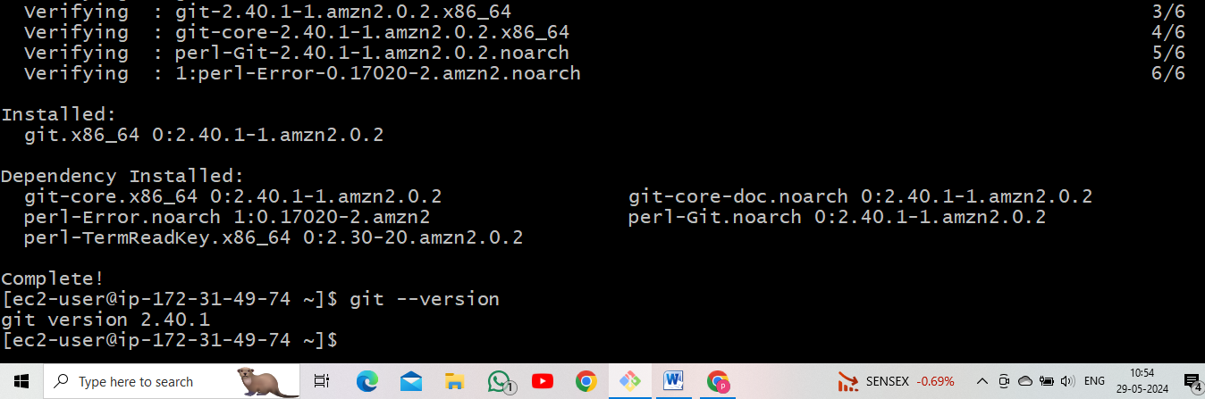

* Install java.

< sudo yum –y install java* >

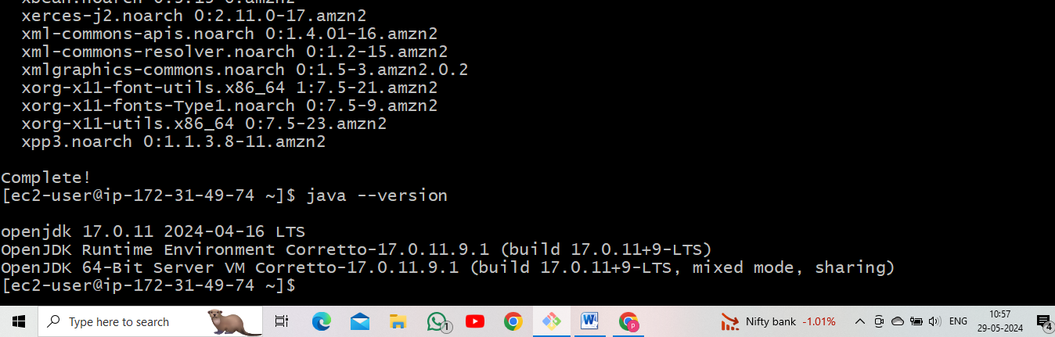

* Install Jenkins.

NOTE: Jenkins installation process is above steps (4th step).

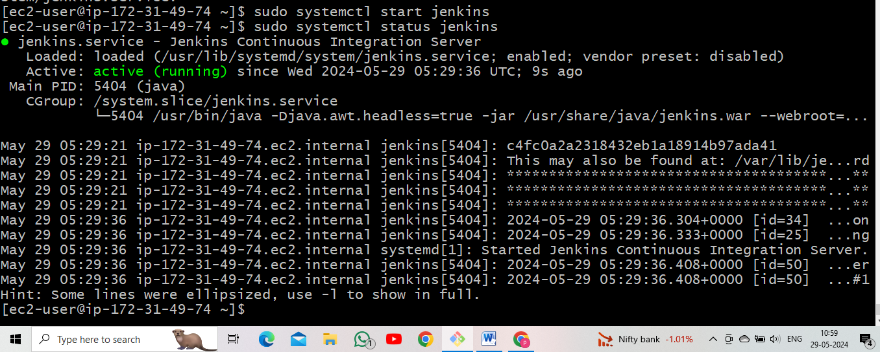

* Go to Git Hub repo.
* Create webhooks.

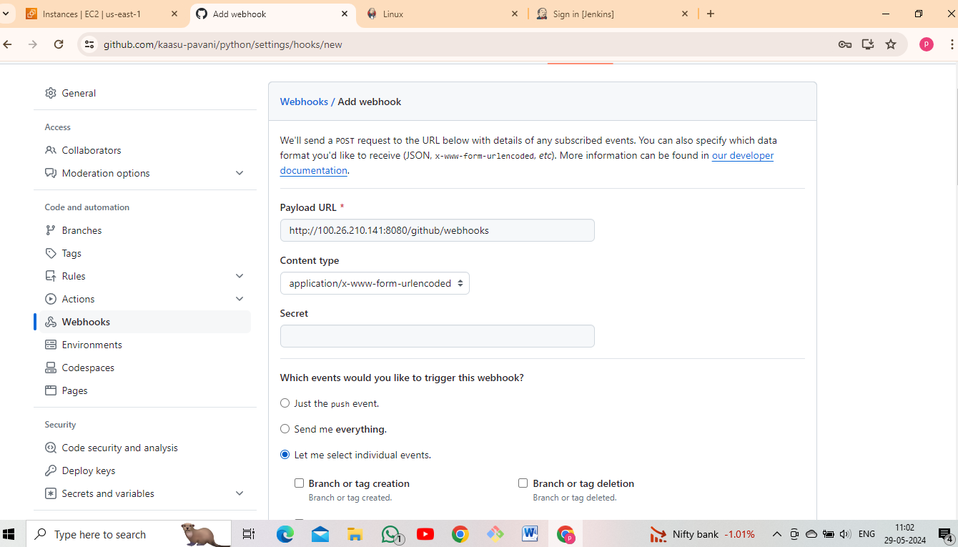

* Go to Jenkins page.
* Create 3 jobs (using pipeline creation).
* After that creating first job.
* Give the Git Hub URL.
* Select Build after other projects are built.

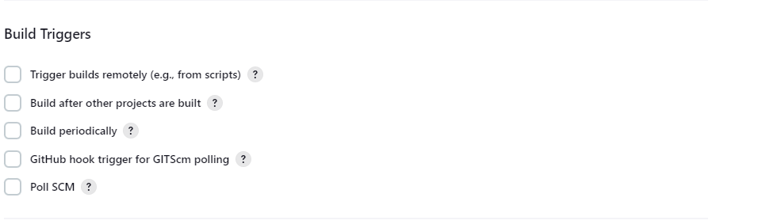

* After that execute shell give the installation of terraform commands and execution of terraform commands.

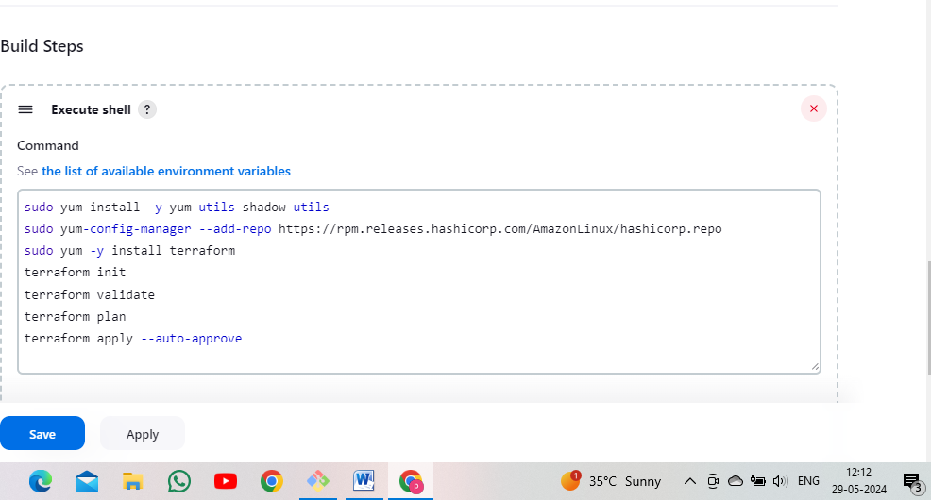

* After that click apply and save and Build now.
* The first job console output as

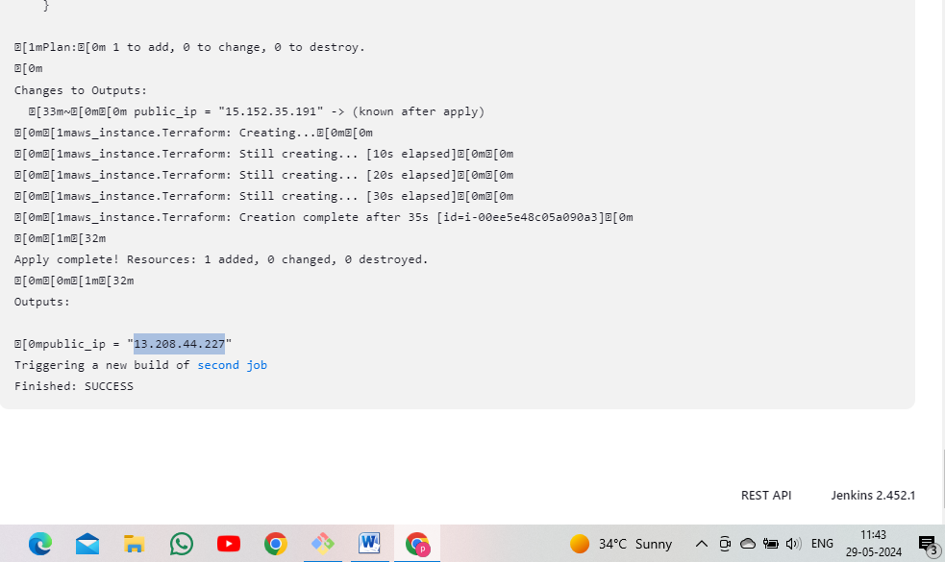

* Console output public copy ip and paste it Google.



* After that go to Jenkins dashboard create new item.
* Select Build after other projects are built.
* Next step is apply and save and Build now.

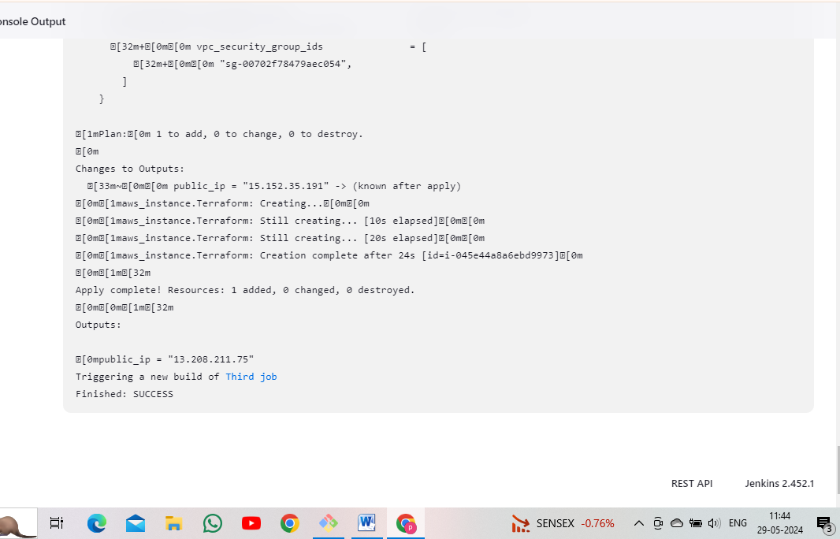

* Console output public ip and paste it Google.



* Same process are repeated in third job creation.
* Go to Jenkins dashboard.
* Create job.
* Select Build after other projects are built.
* After that click apply and save and Build now.

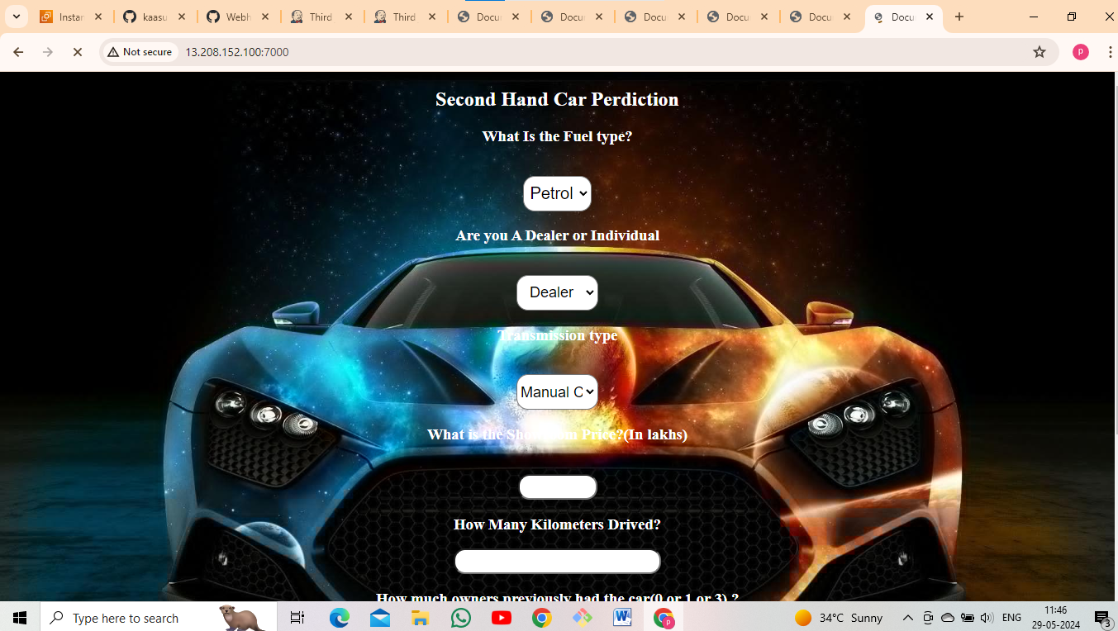

* Next step is creating pipeline.
* Jenkins Dashboard->manage Jenkins->available plugins->search for Build pipeline and install.

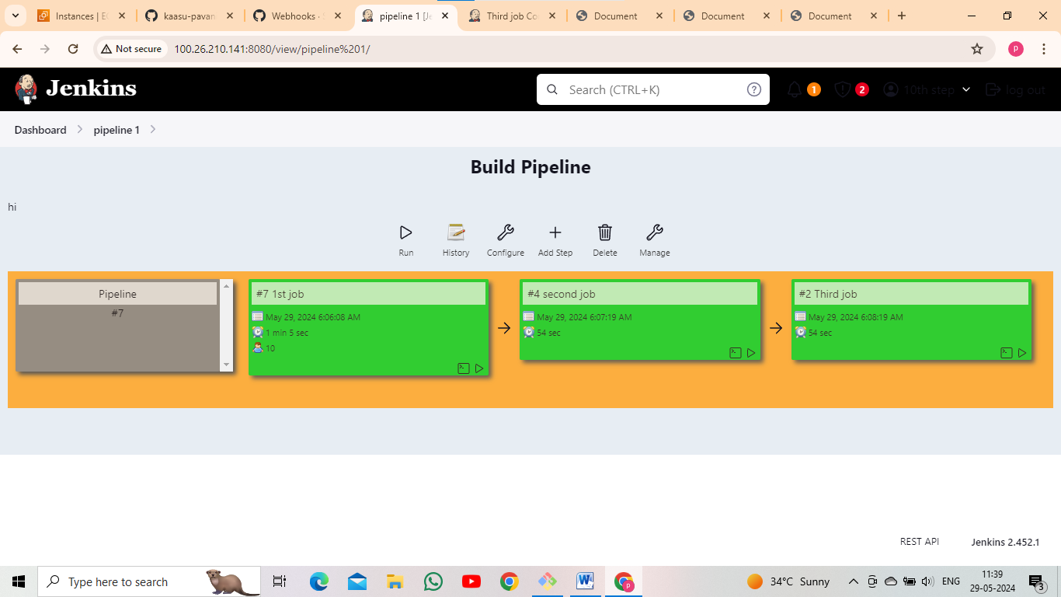

**\*\*\*\*\*\*\*\*\*\*\*\*\*\*\*THE END\*\*\*\*\*\*\*\*\*\*\*\*\*\*\*\*\***